**Name : Ch Mubashir SAP : 56892.**

**All Lab Tasks ( 1- 11):**

**Lab 01 :**

**56892_CH Mubashir_Task_1**

Q1(1):

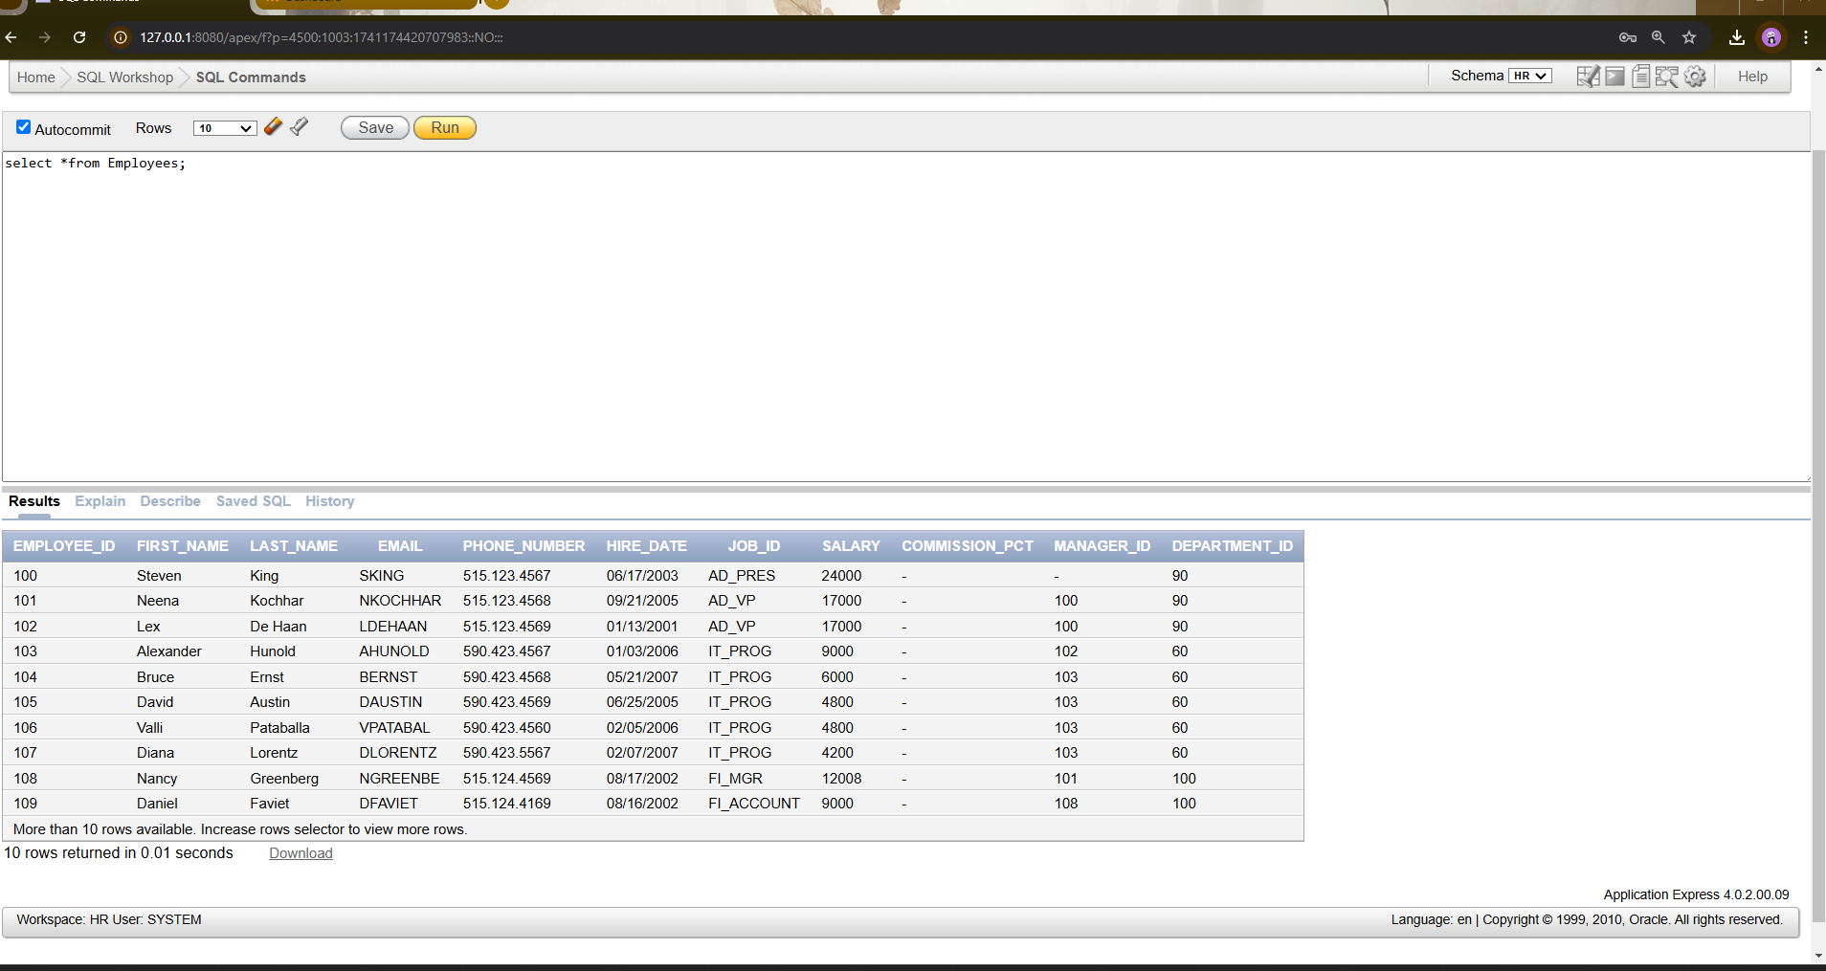

Q1(2):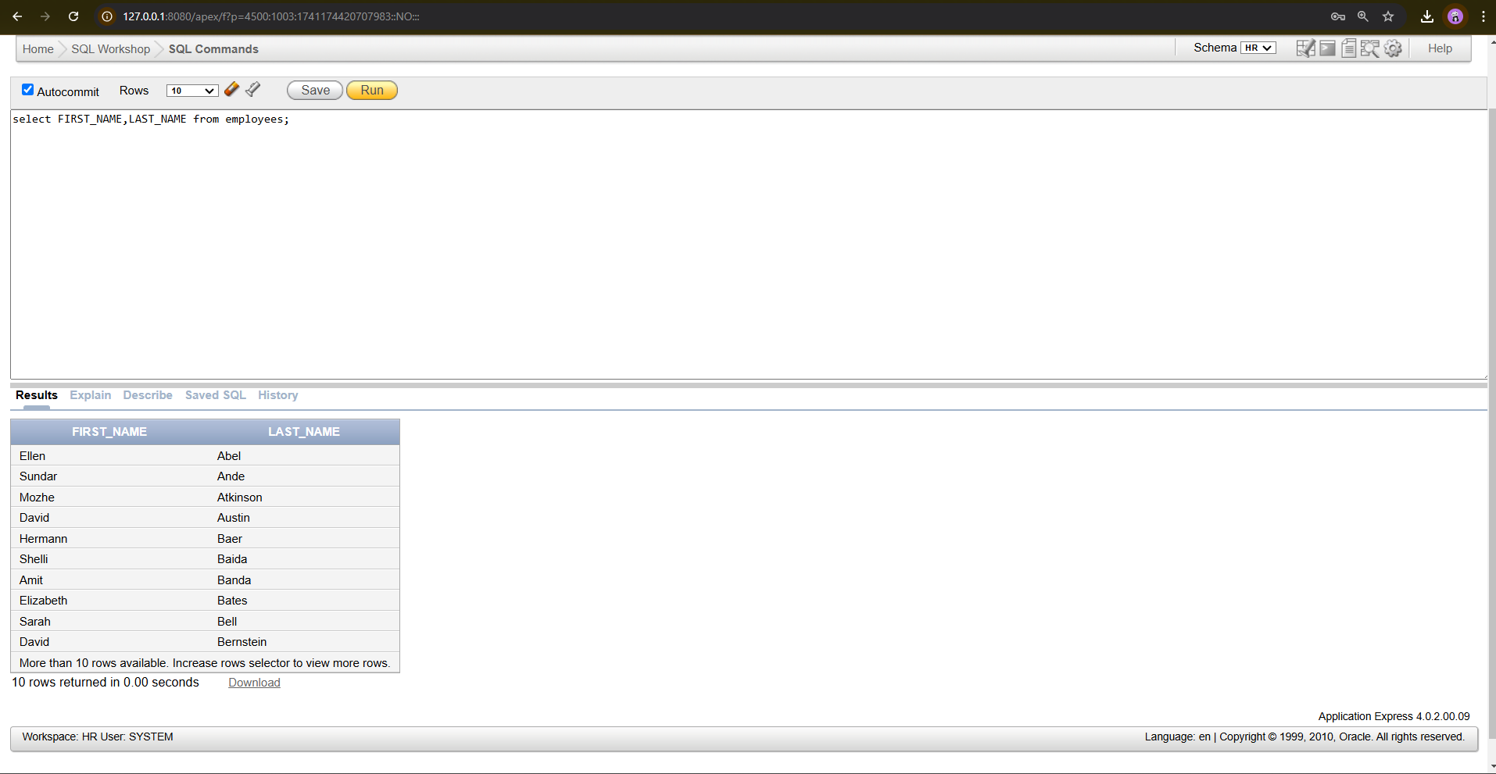

Q1(3):

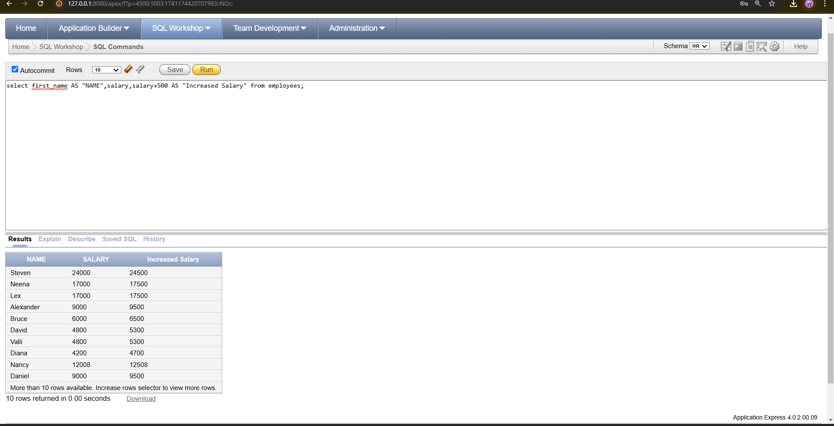

Q1(4):

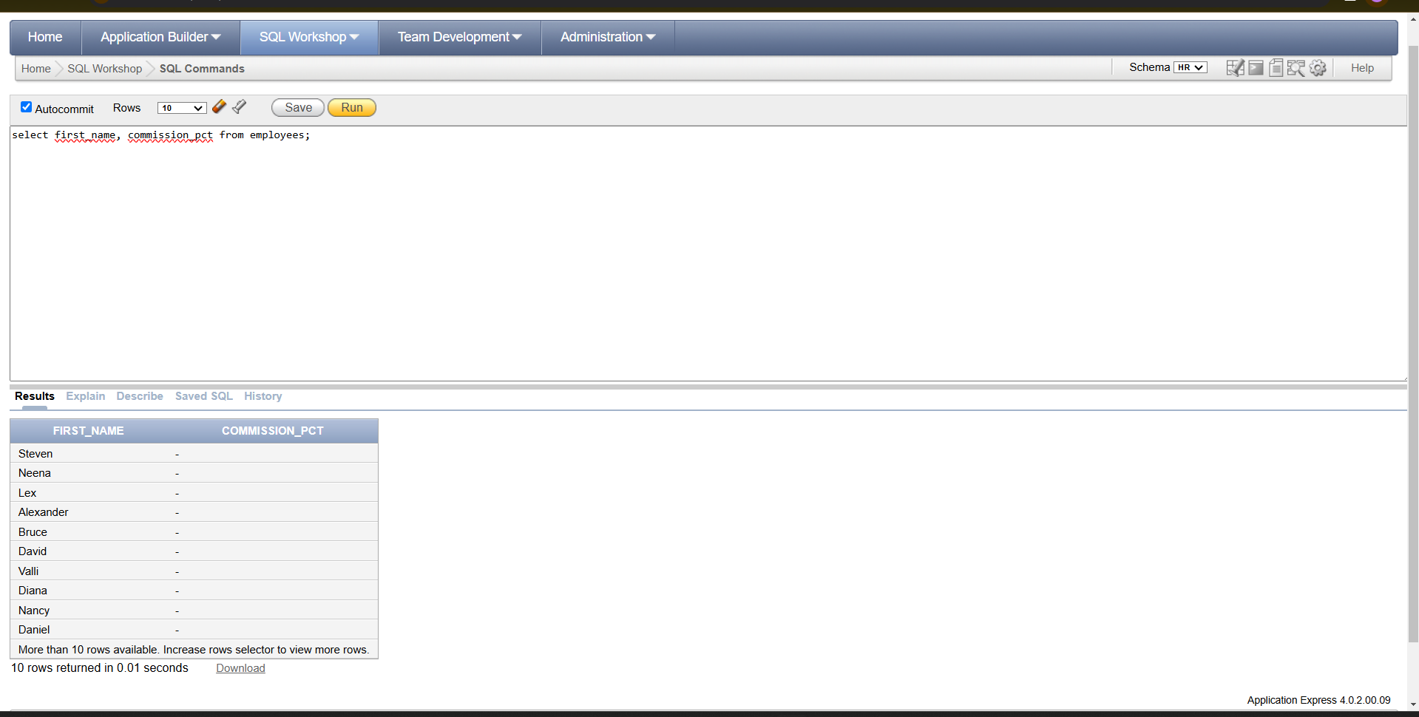

­­­­

Q1(5):

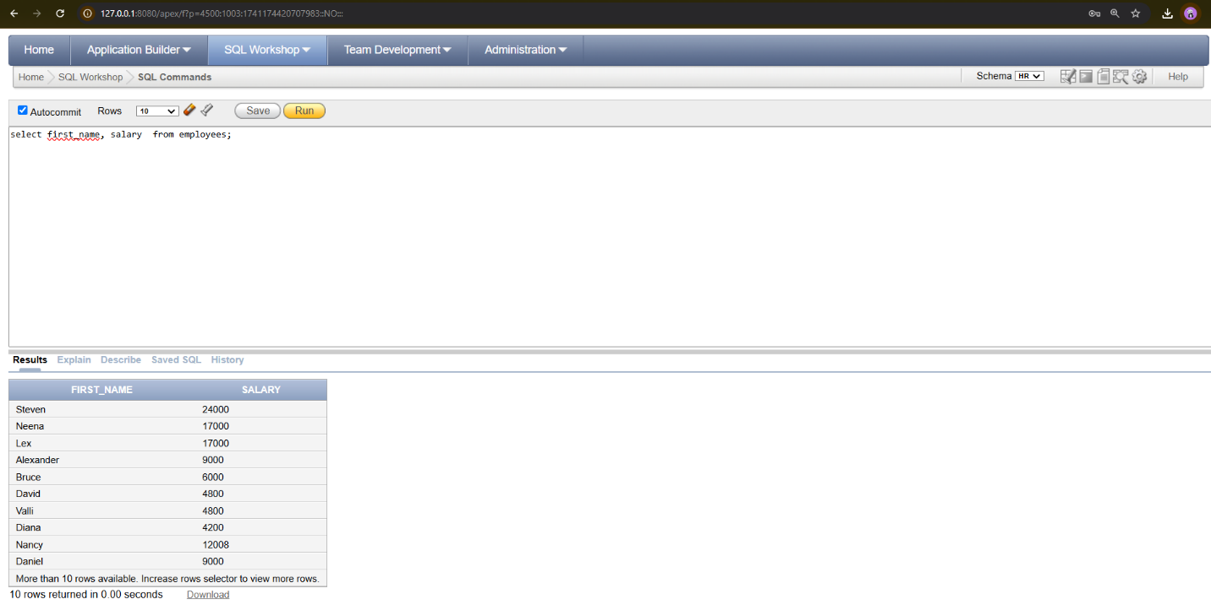

Q2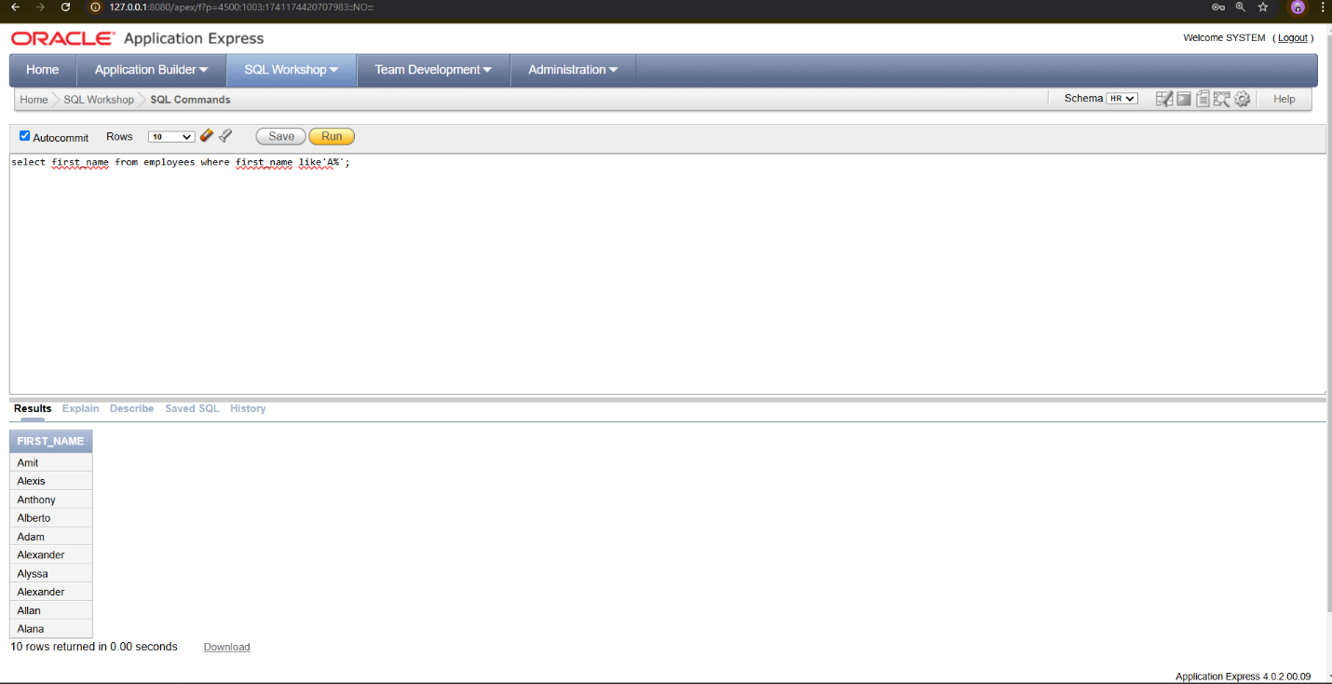

Q3:

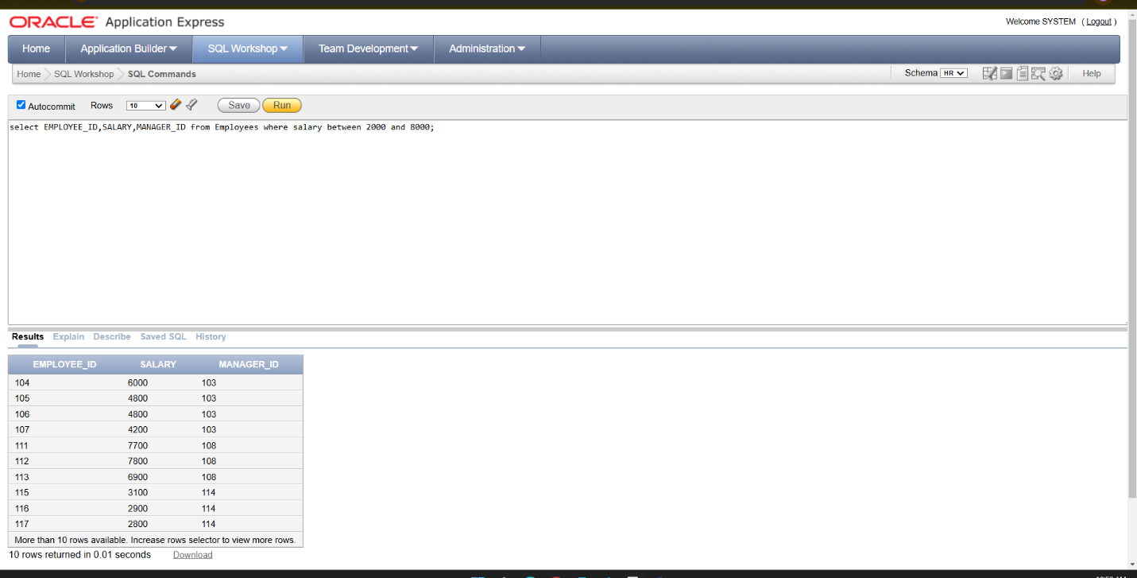

**Lab 02 :**

**Logical operators :**

**AND Operator :** **Ex 1**

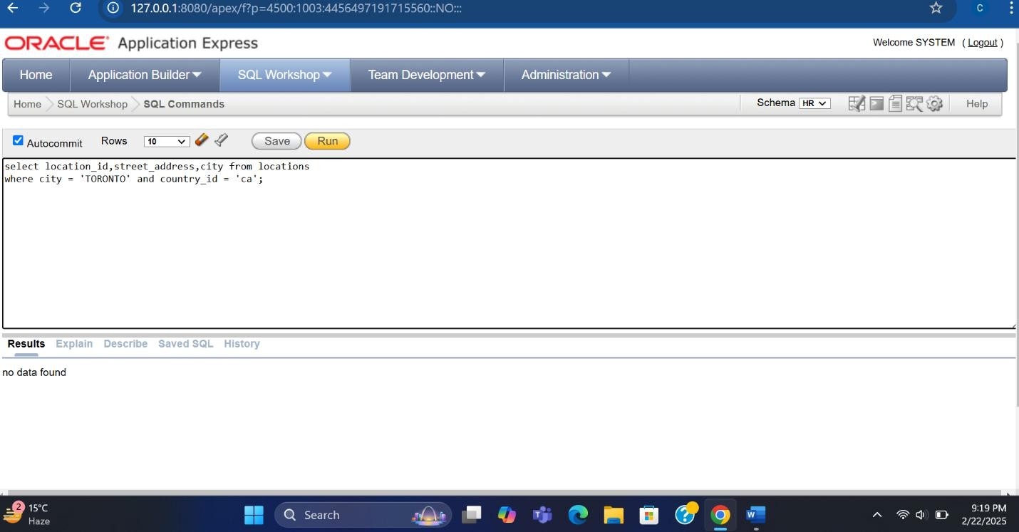

**Ex 2:**

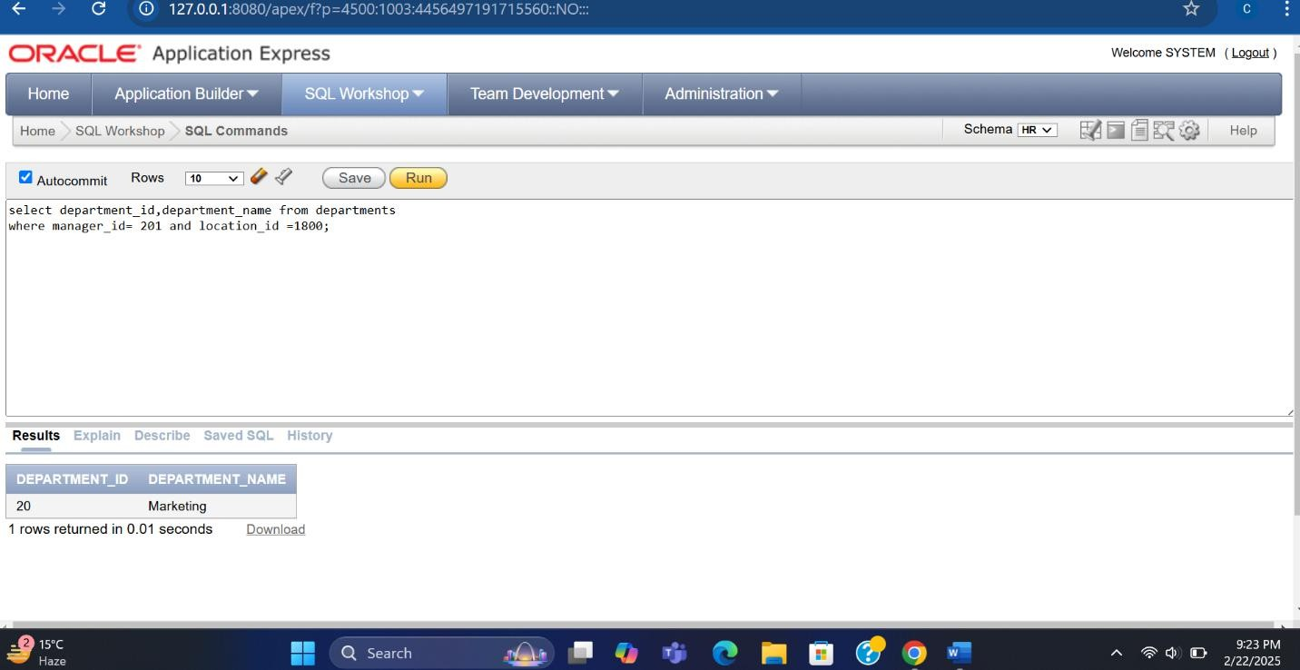

**Ex 3:**

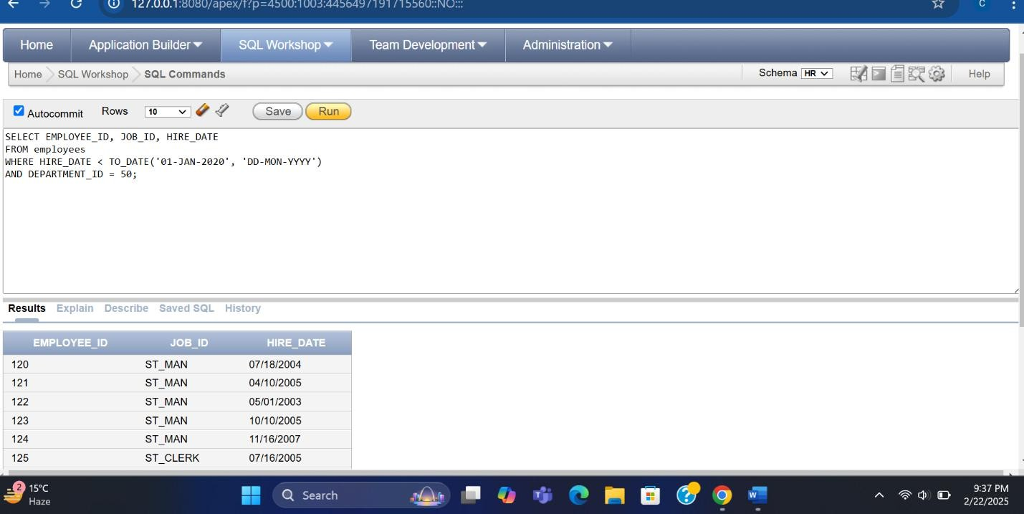

**OROperator:**

**Ex 1 :**

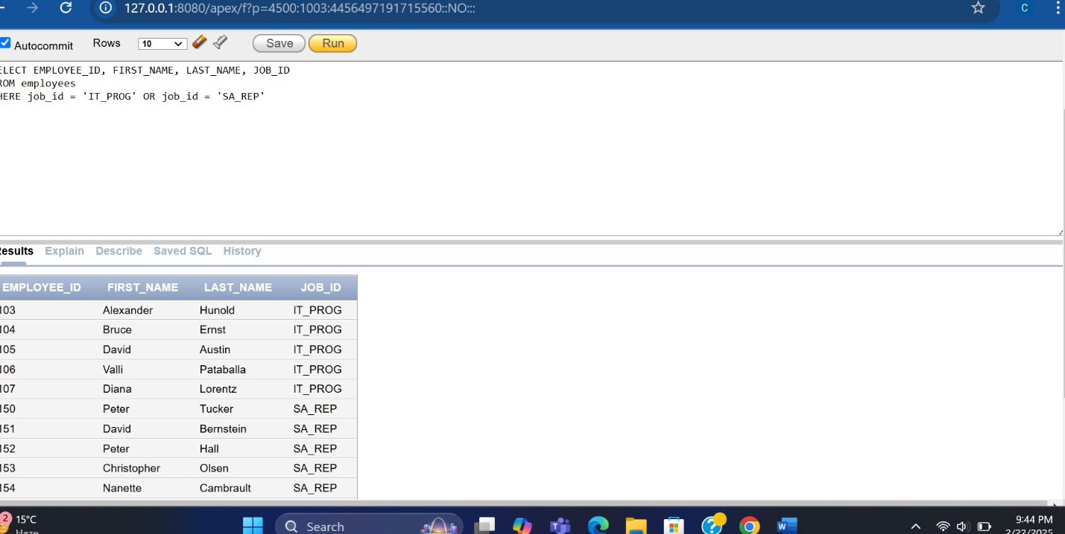

**Ex 2:**

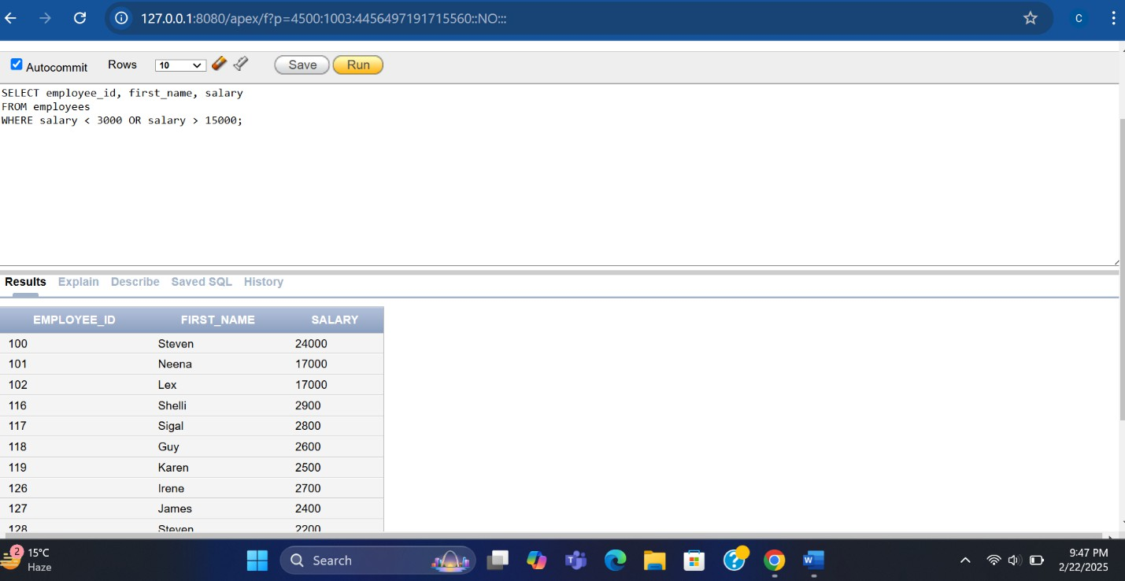

**Ex 3:**

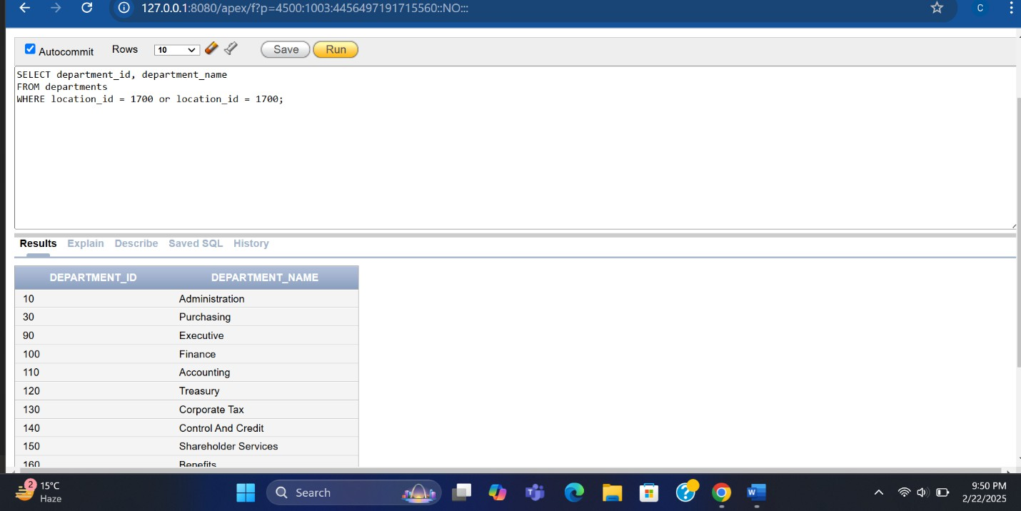

**Ex 4:**

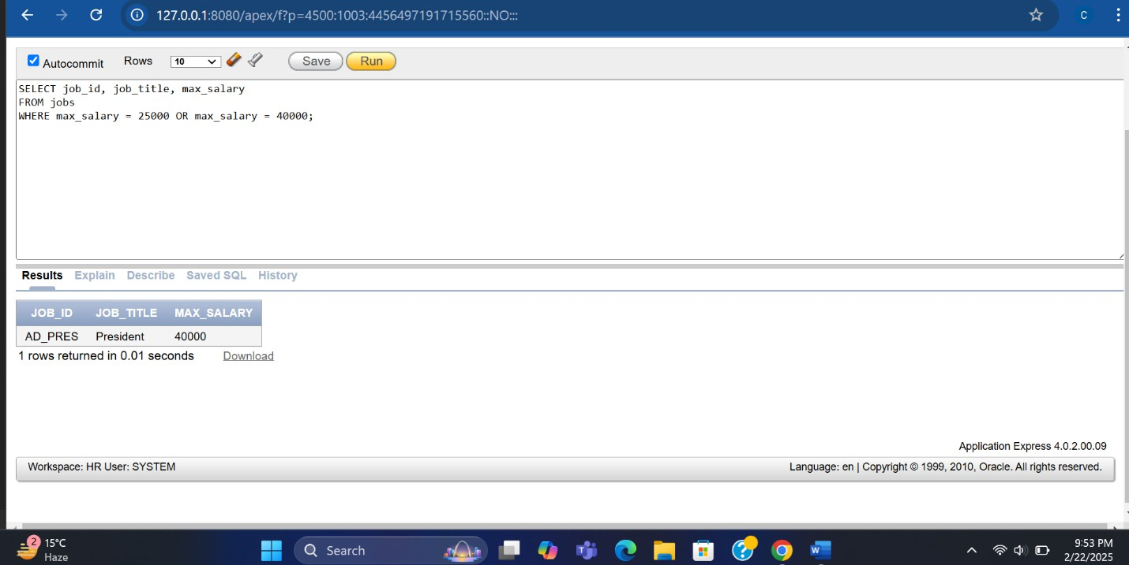

**Ex 5 :**

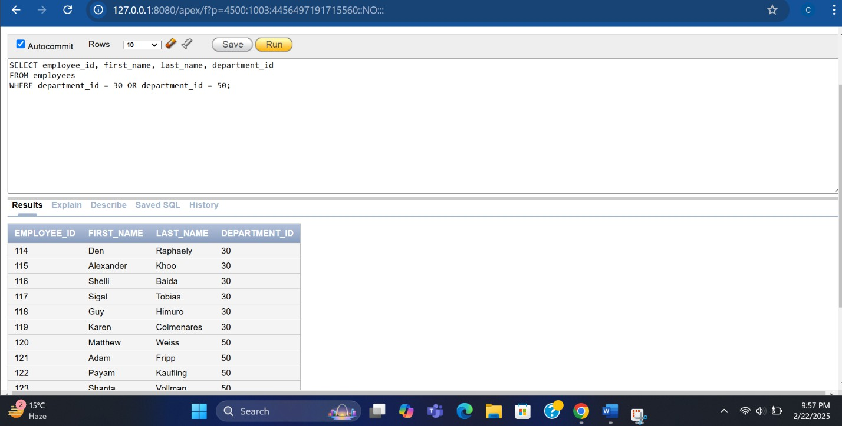

NOT Operator Returns TRUE if the following condition is FALSE

**Ex 1**

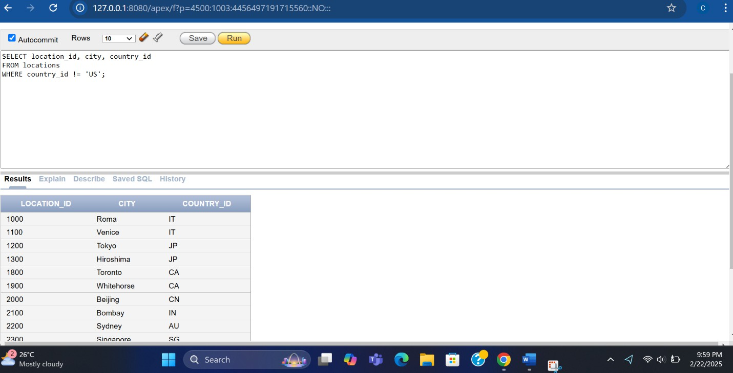

**Ex : 2**

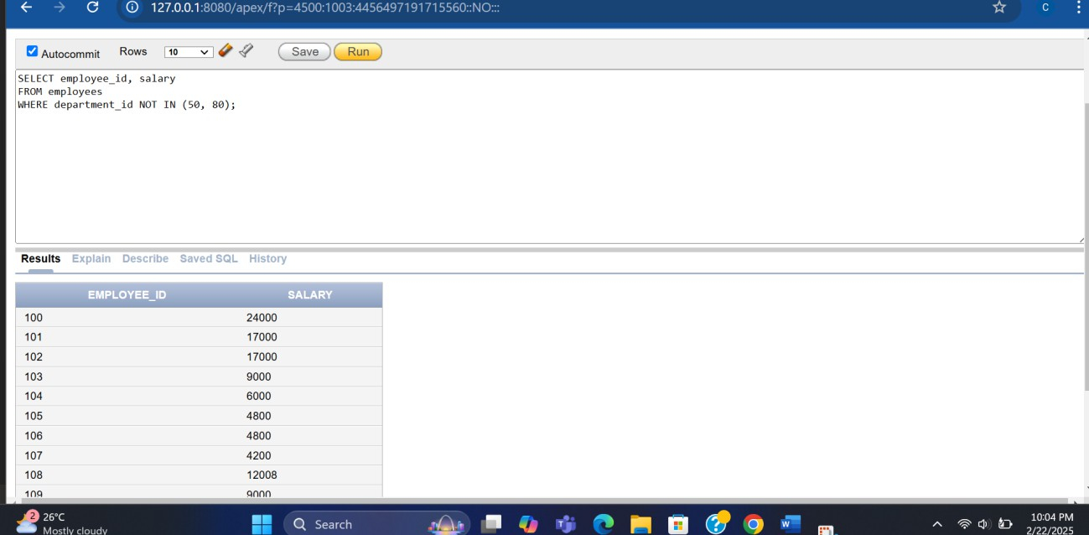

Order by clause Ex : 1

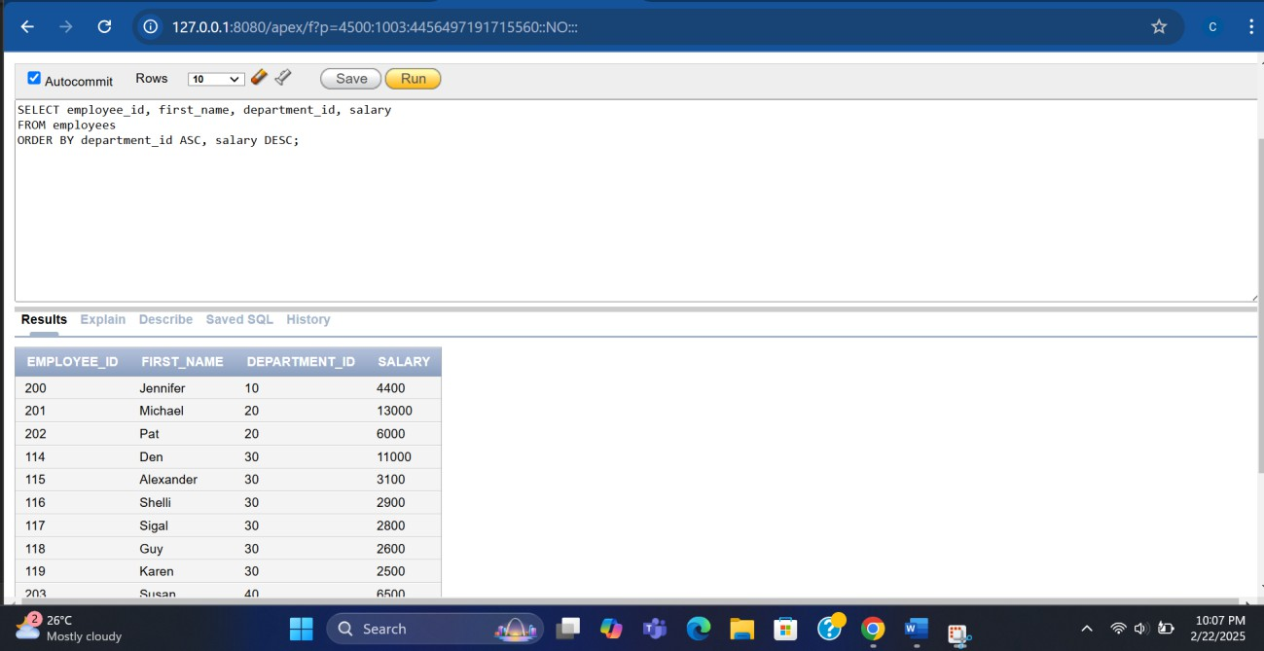

***EX 2:***

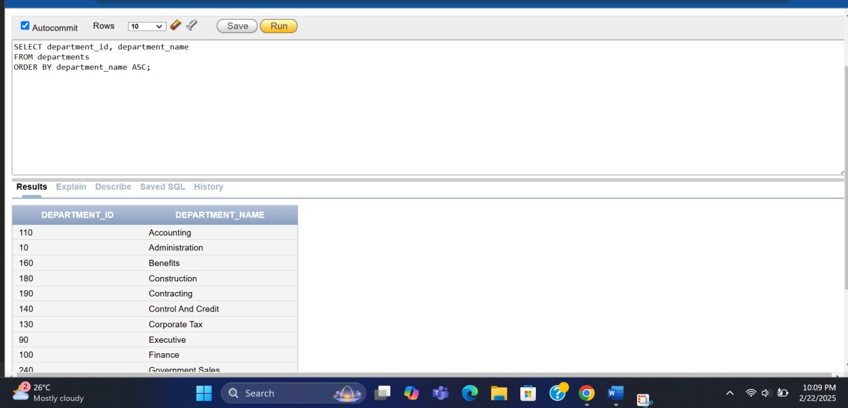

**Q2 :**

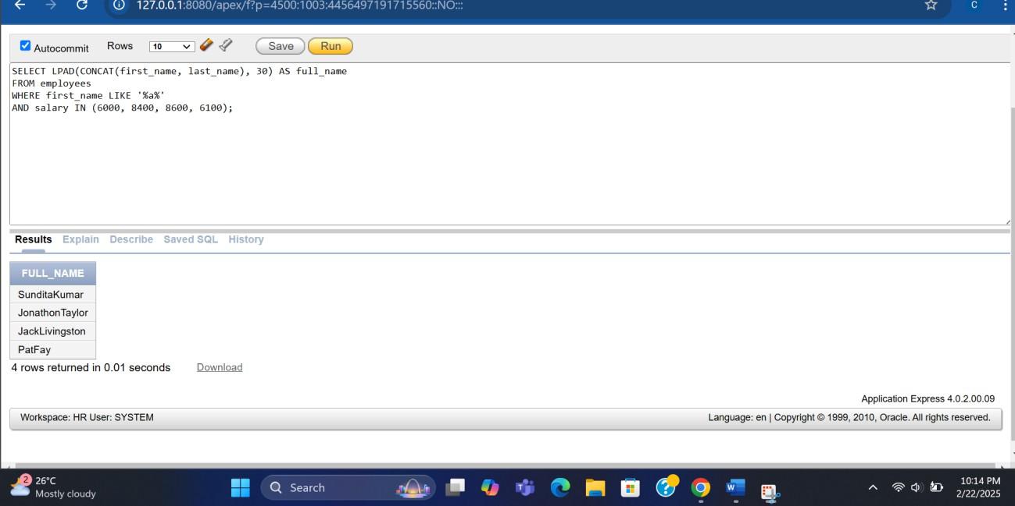

**Lab 03 :**

**Write a query to convert country names to lowercase and display country details.**

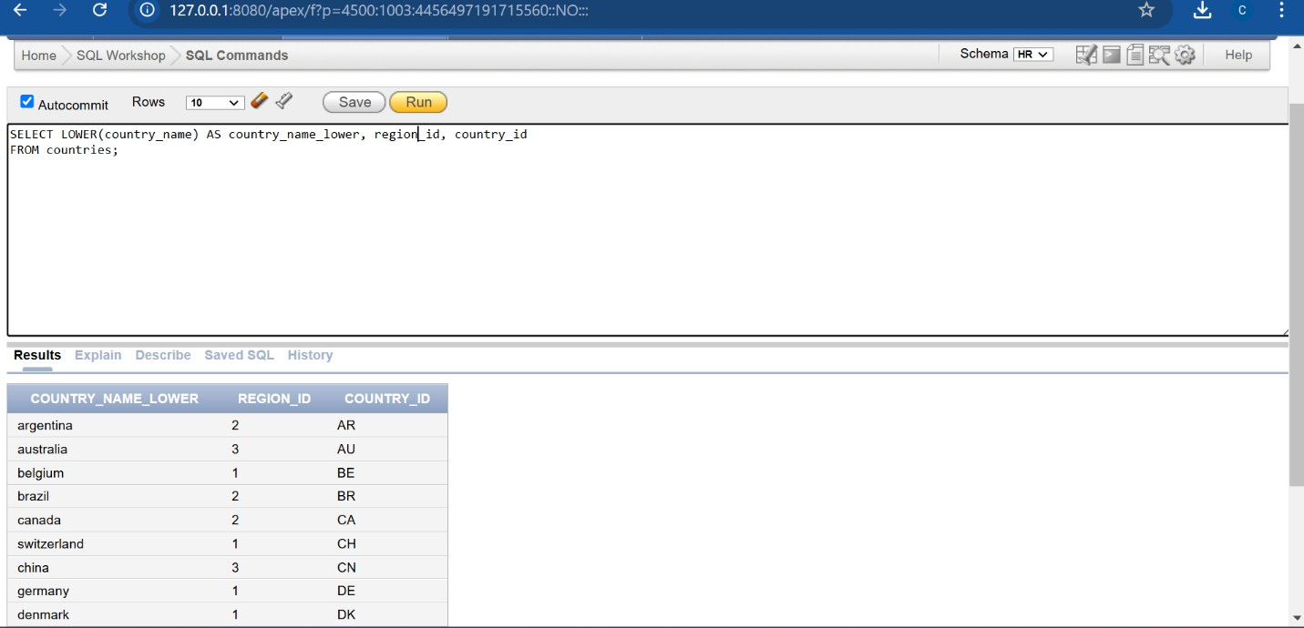

**Write a query to convert employee first and last names to uppercase and filter employees whose salary is between 6000 and 12000.**

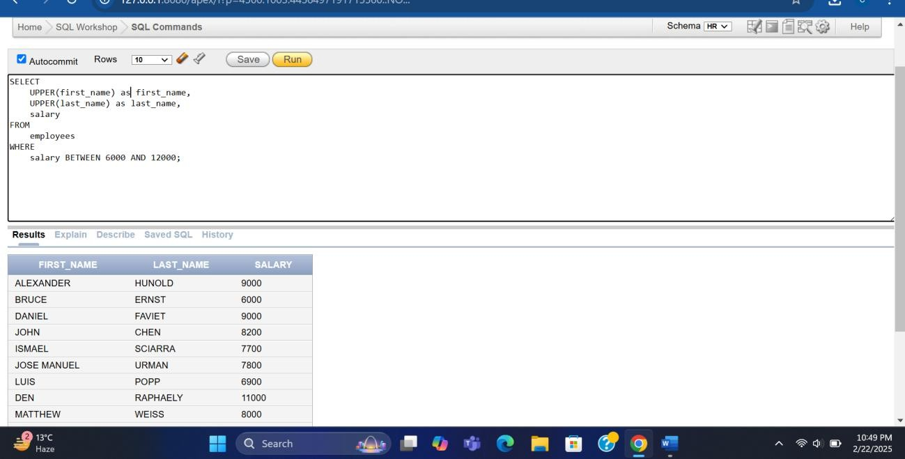

Write a query to calculate the remainder when an employee's salary is divided by their commission percentage for employees with the job ID 'SA_REP'.

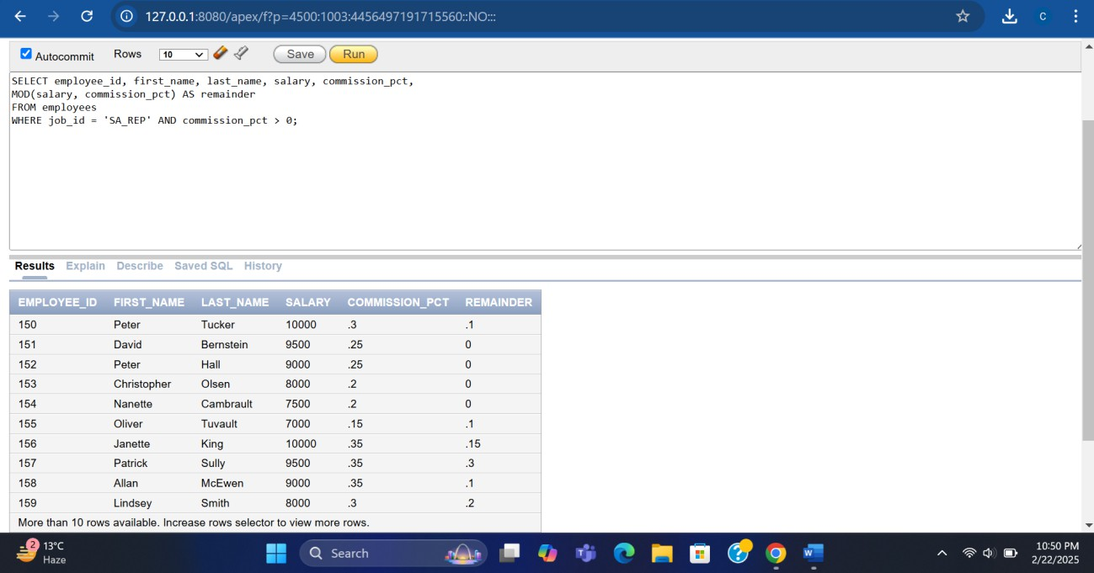

Write a query to retrieve employees whose salaries are even numbers using the MOD function.

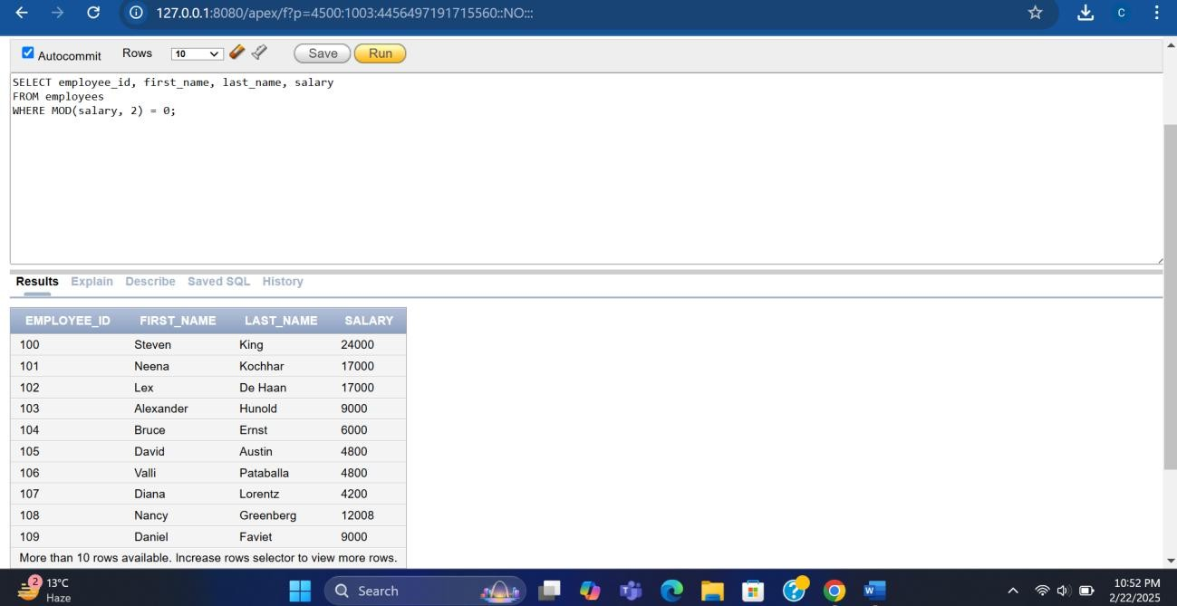

Write a query to calculate the number of months an employee has worked using the ROUND and MONTHS_BETWEEN functions.

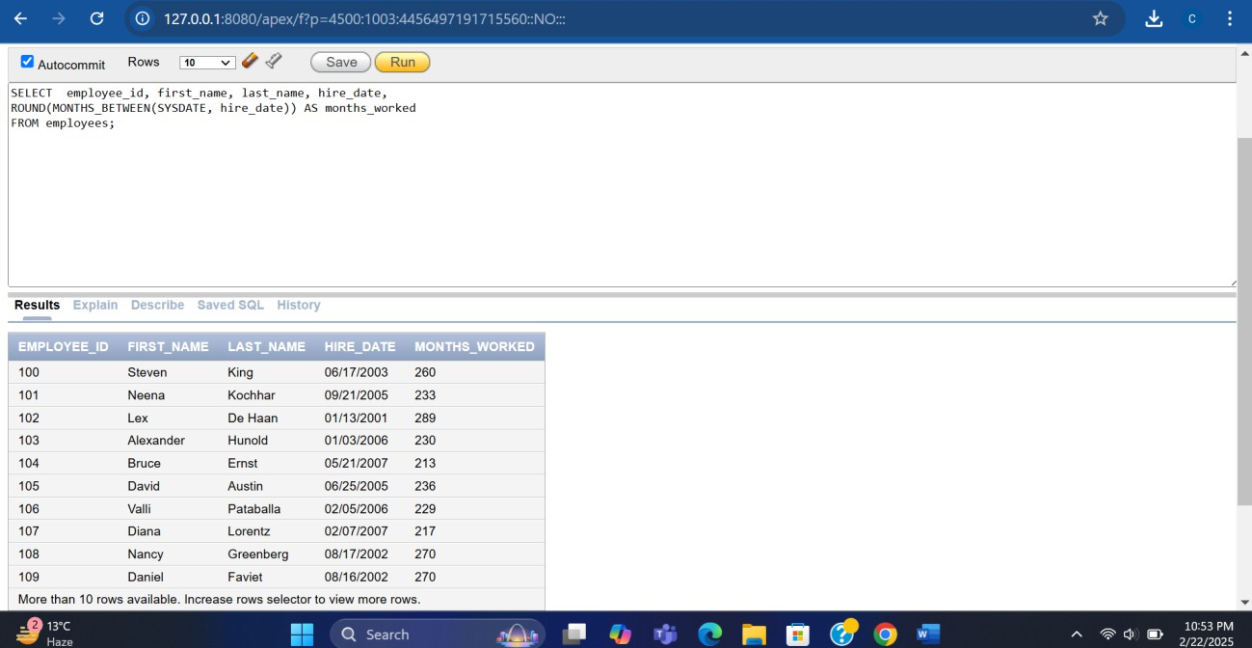

* + **Write a query to display employee names and replace NULL commission percentages with 99 using the NVL function.**

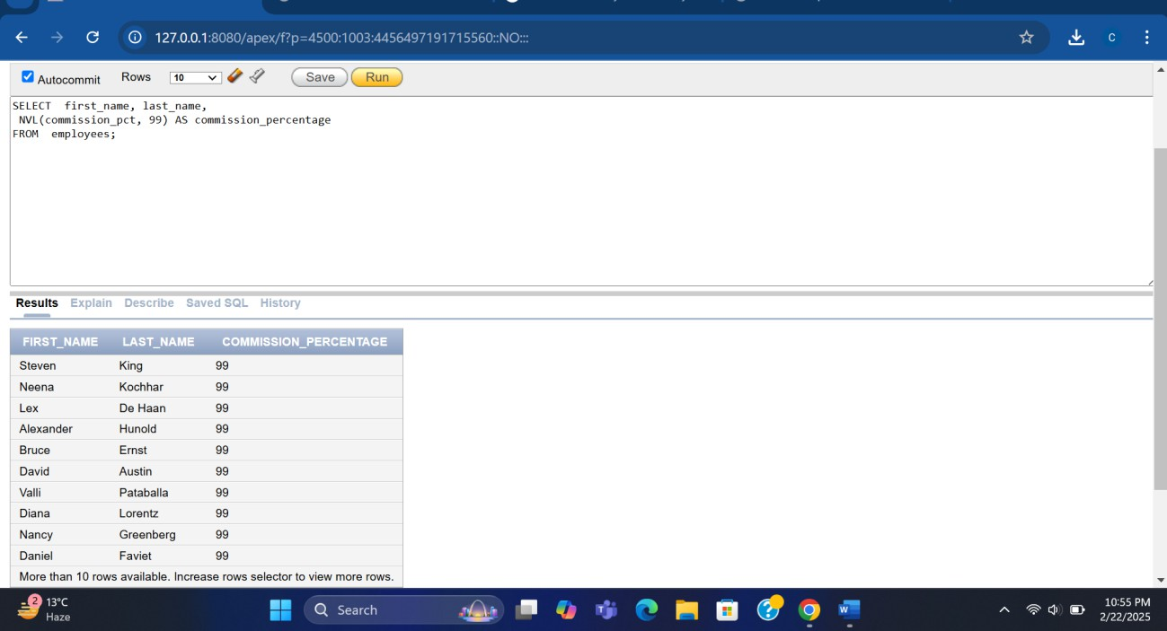

**Lab 04 :.**

**Question 1 :**

**You are required to implement all the queries mentioned in the examples. Example :**

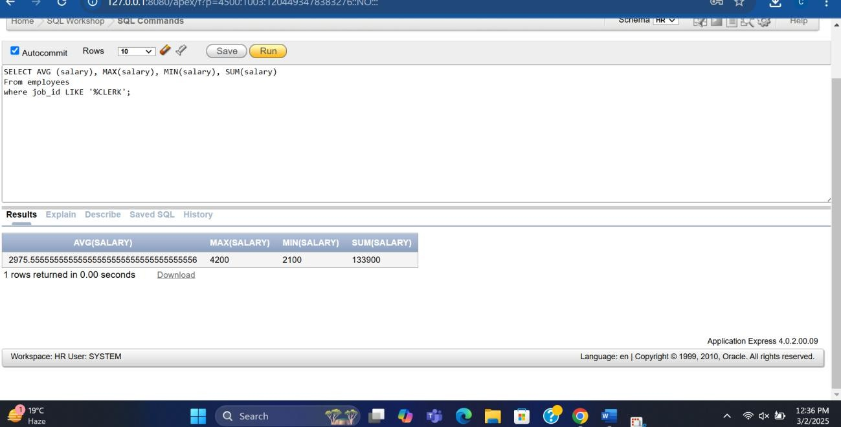

Example :

**Find the highest and lowest salary for each department.**

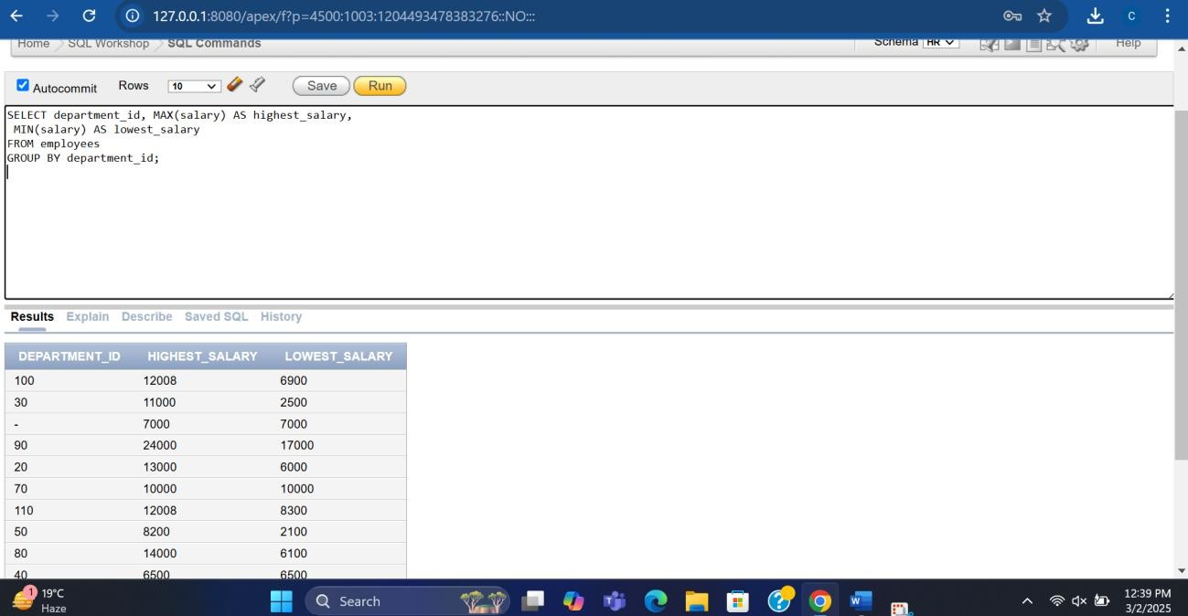

Example : 3

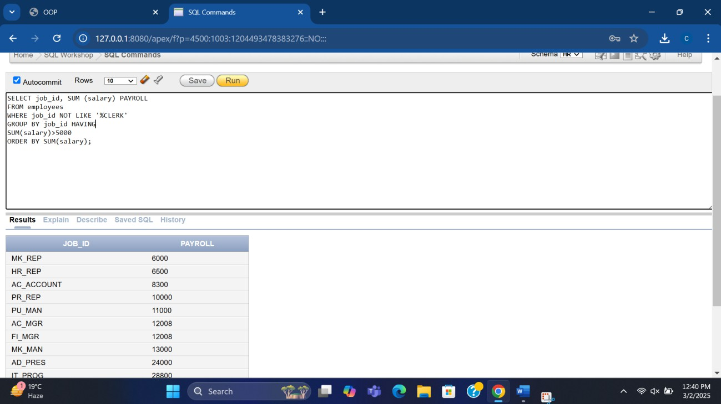

**The above example displays the job title and total monthly salary for each job title with a total payroll exceeding 5000. It also exclude salespeople and sorts the list by the total monthly salary.**

Question 2

Show the average salary of all those employees whose first_name contains 'a' and 'e';

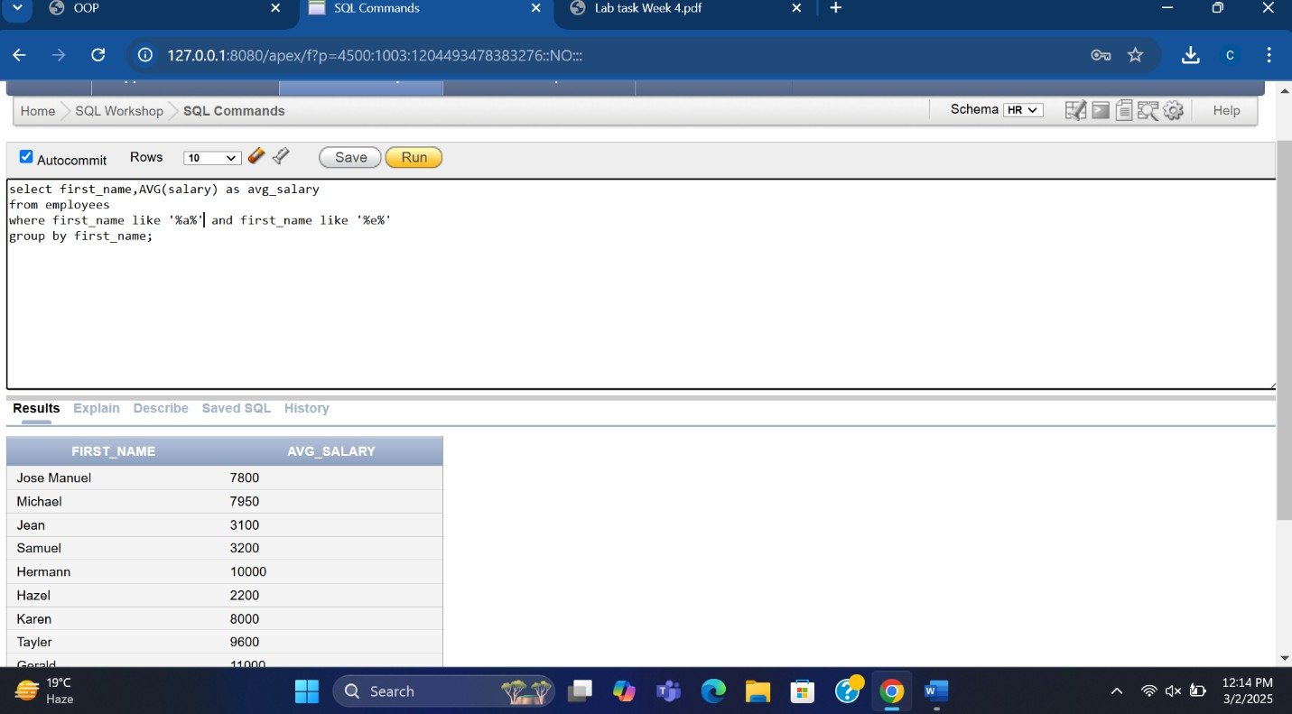

Question : 03

Display the highest, lowest, sum, and average salary of all employees. Label the columns Maximum, Minimum, Sum, and Average, respectively. Round your results up to the two decimal position.

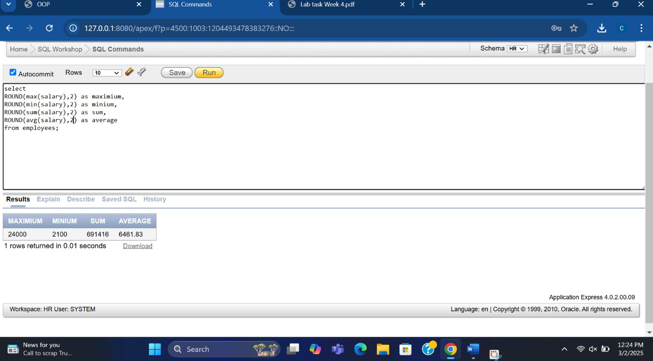

# Question : 4

Modify the above questions to display the minimum, maximum, sum, and average salary for each job type.

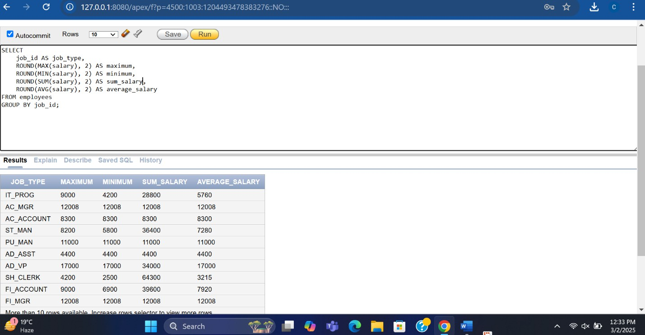

# Question : 05

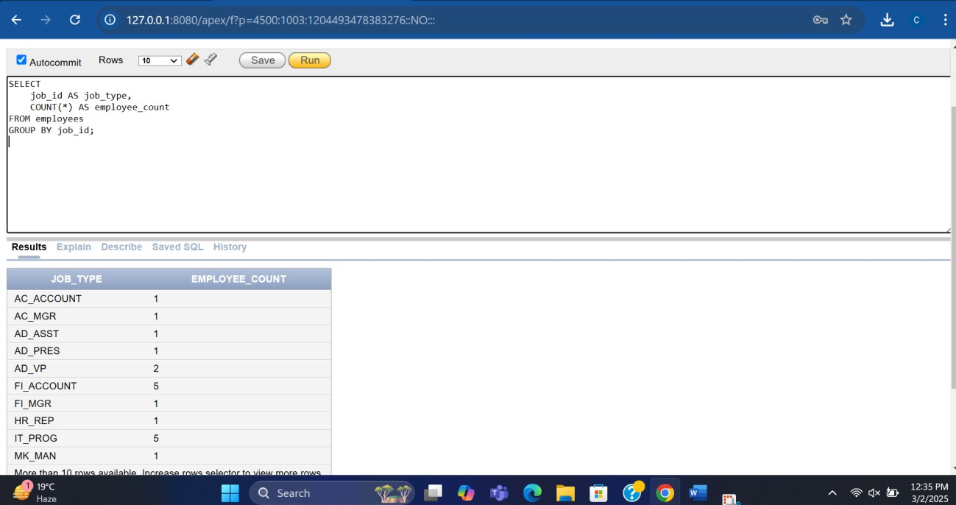Write a query to display the number of people with the same job.

**Lab 05 :**

# Display the report of all those employees whose income is less than those who work in any department numbers 50, 20, and 10.

1. **: The HR department needs a report that displays the last name, department number, and job ID of all employees whose department location ID is 1700.**

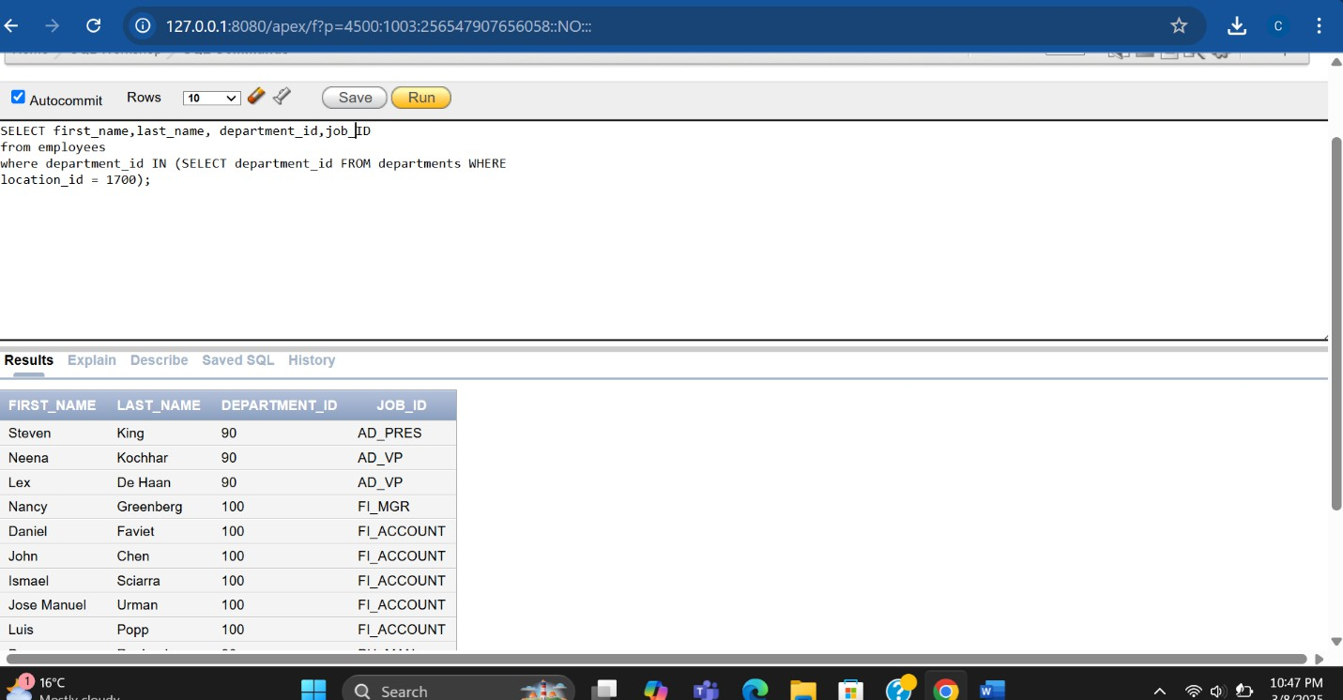

1. 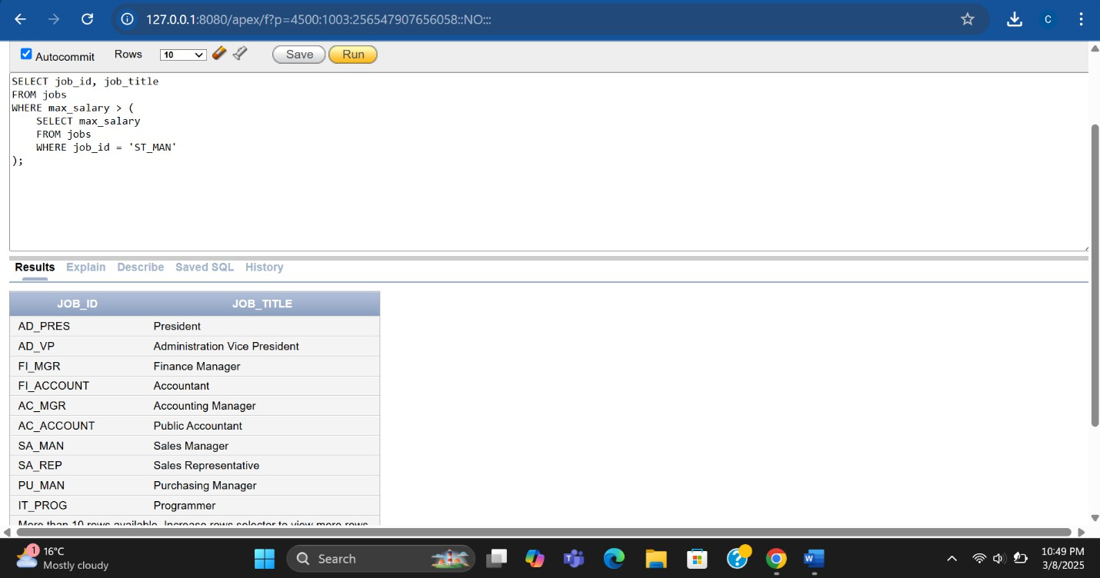Display the job number and job title of those employees whose maximum salary is greater than 'ST_MAN' from job table.
2. **Show a report that displays the employee number, first name, and salary of all employees who earn more than the average salary. Sort the results according to salary in ascending order.**

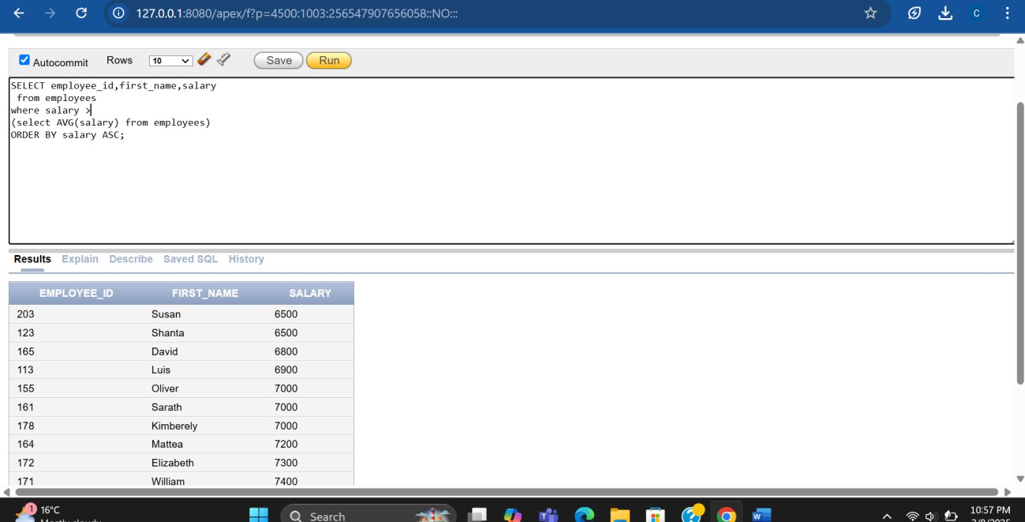

1. 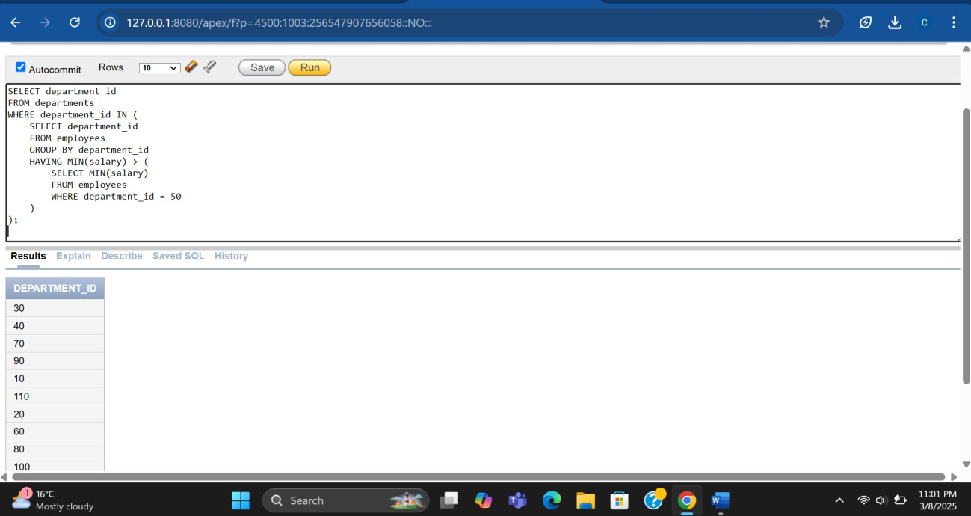**Display all the departments that have a minimum salary greater than that of department 50 .**

**LAB TASK 06 :**

**Example :**

INNER JOIN (simple join)

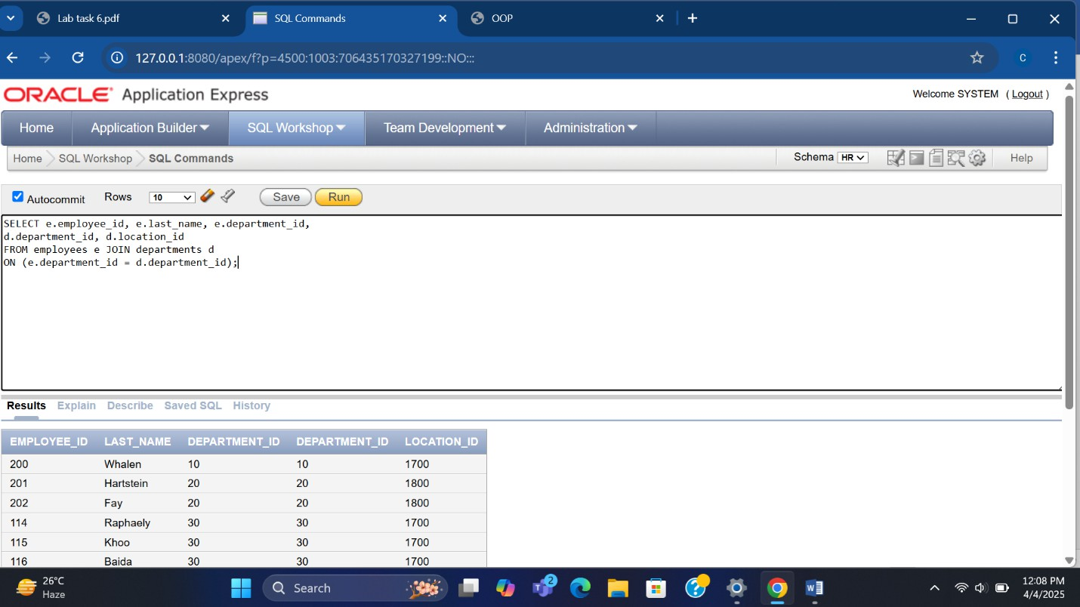

LEFT OUTER JOIN or LEFT JOIN :

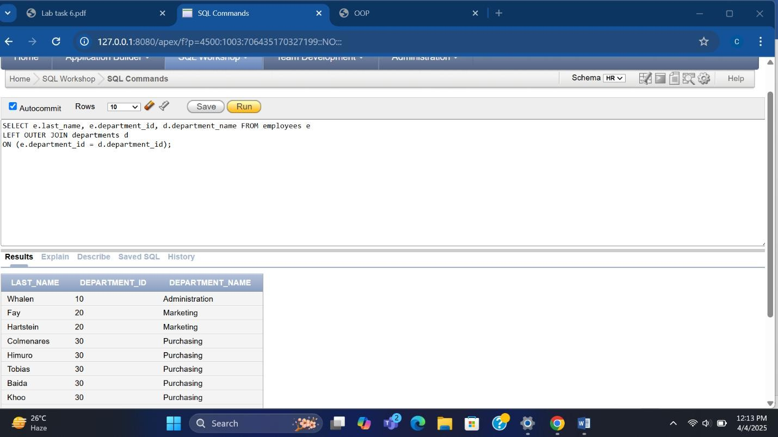

Right Outer join :

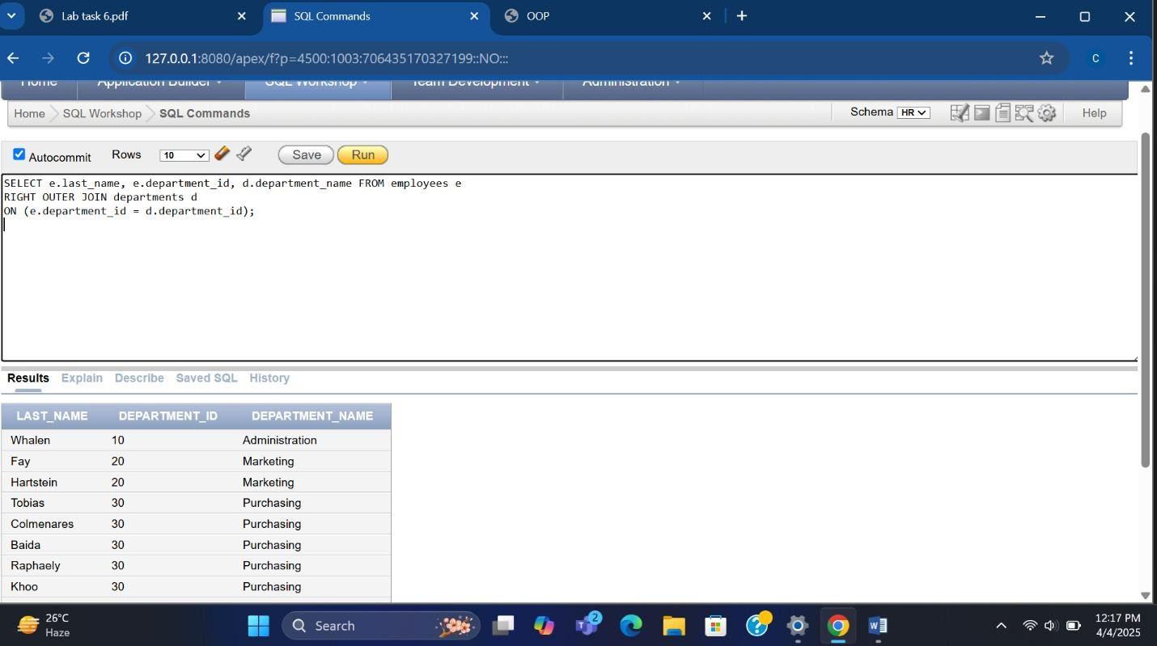

Full Outer join :

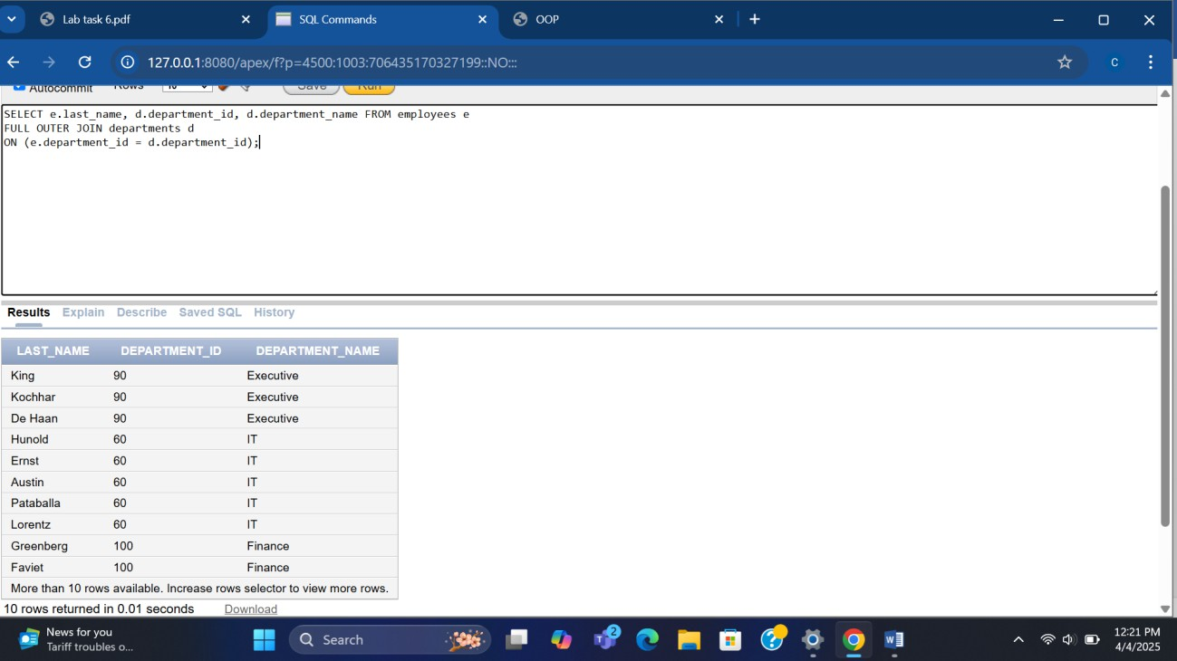

**Self Join :**

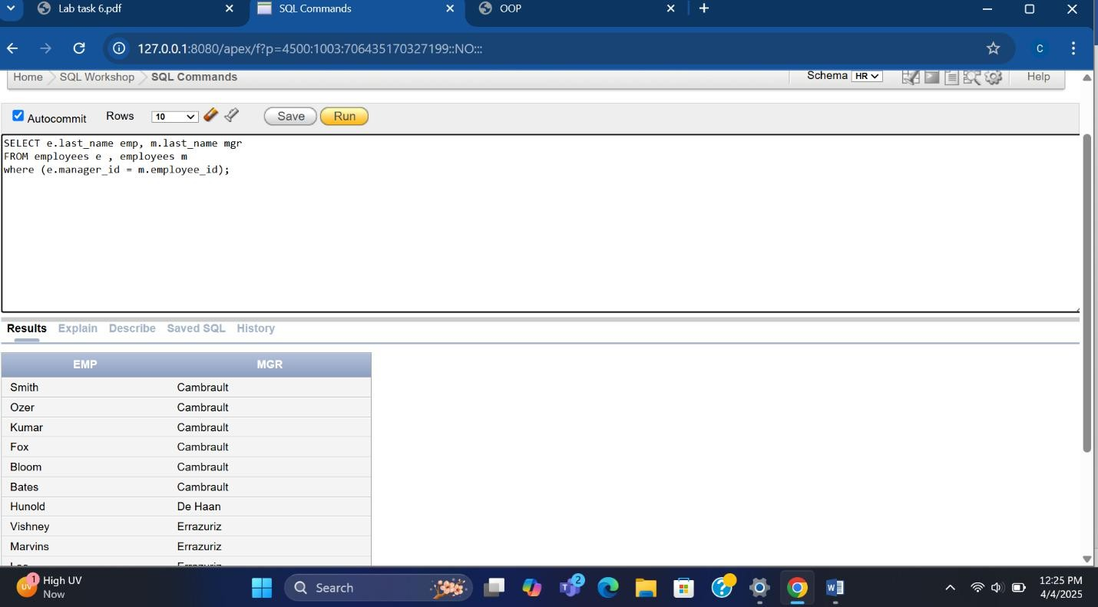

Cross join :

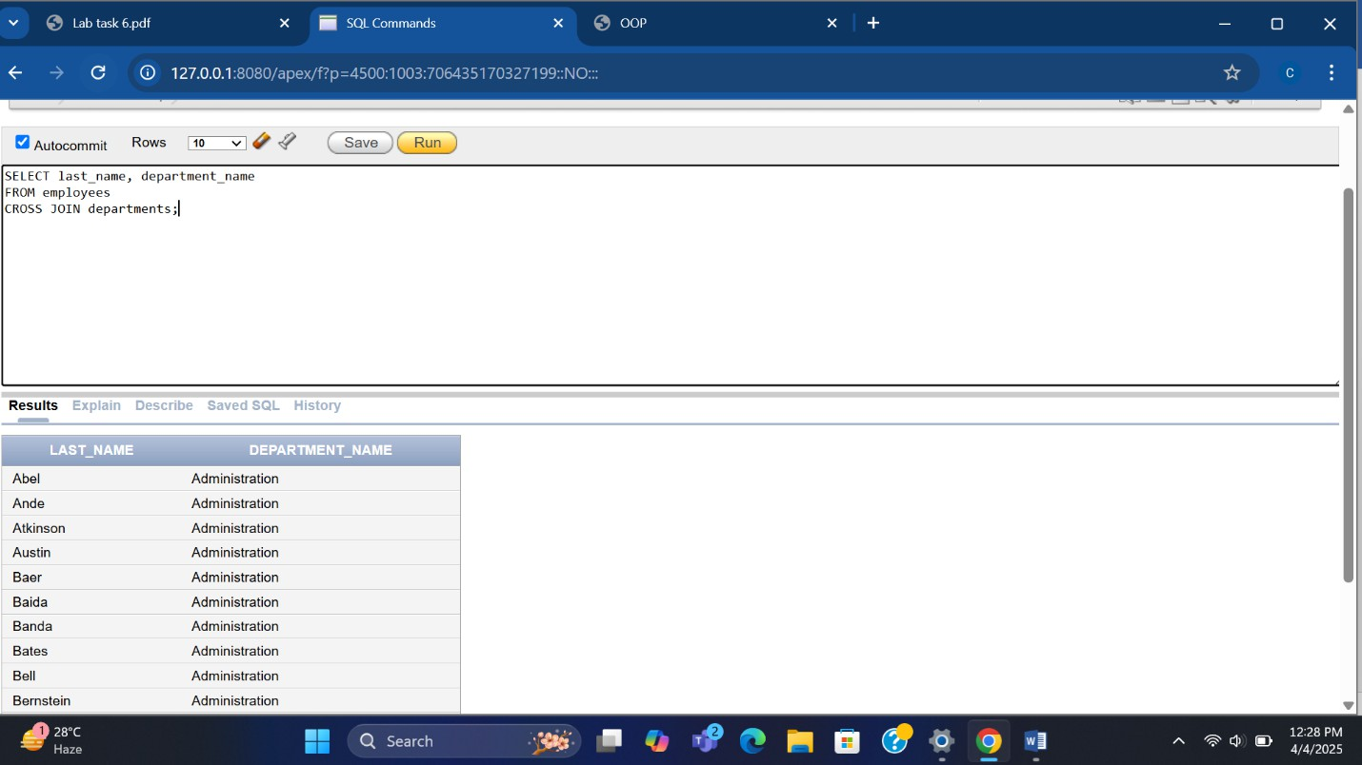

Execerise :

Write a query that displays the job-id, employee last name, department id for all employees whose employee job-id is equal to job job-id.

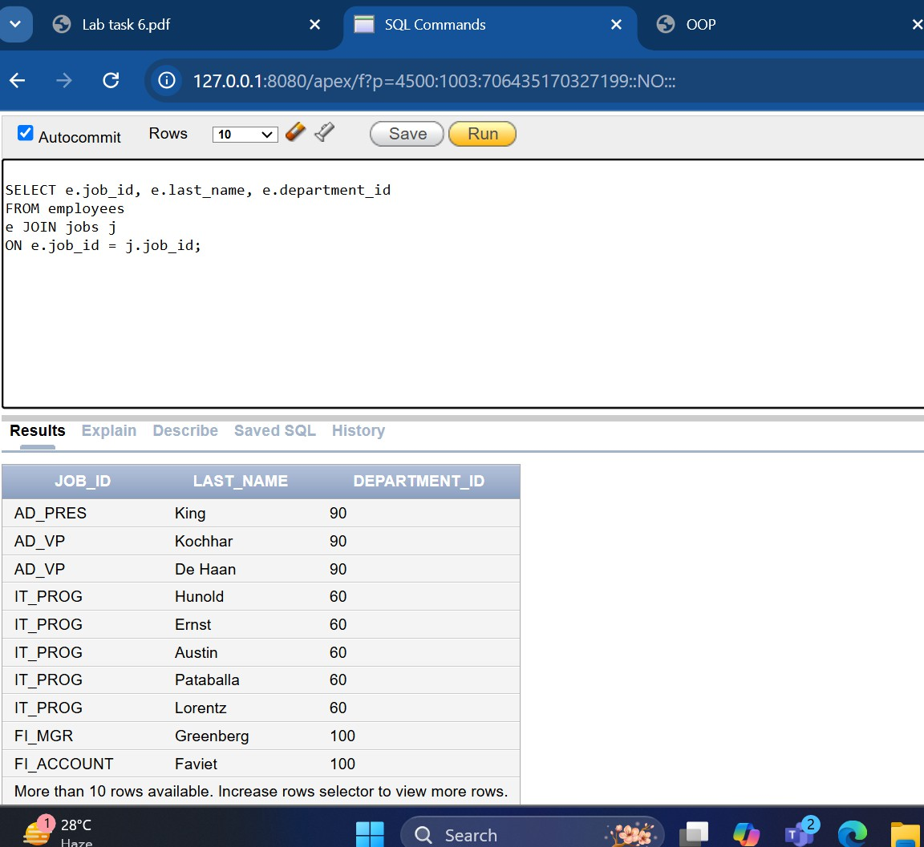

. Write a query to display employees’ last name and employee number along with their

manager’s last name and manager number. Label the columns Employee, Emp#, Manager, and

Mgr#, respectively.

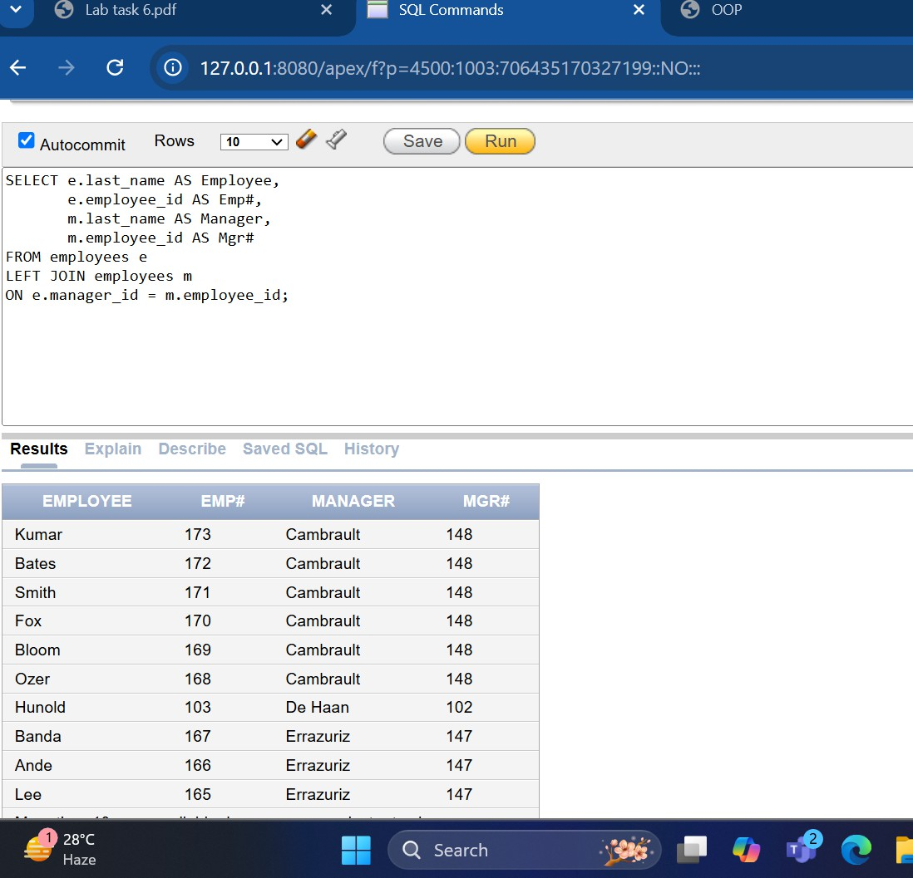

Q4. Write a query to join employees, job_history, and departments table to get the employee name, job title, and department name of each employee.

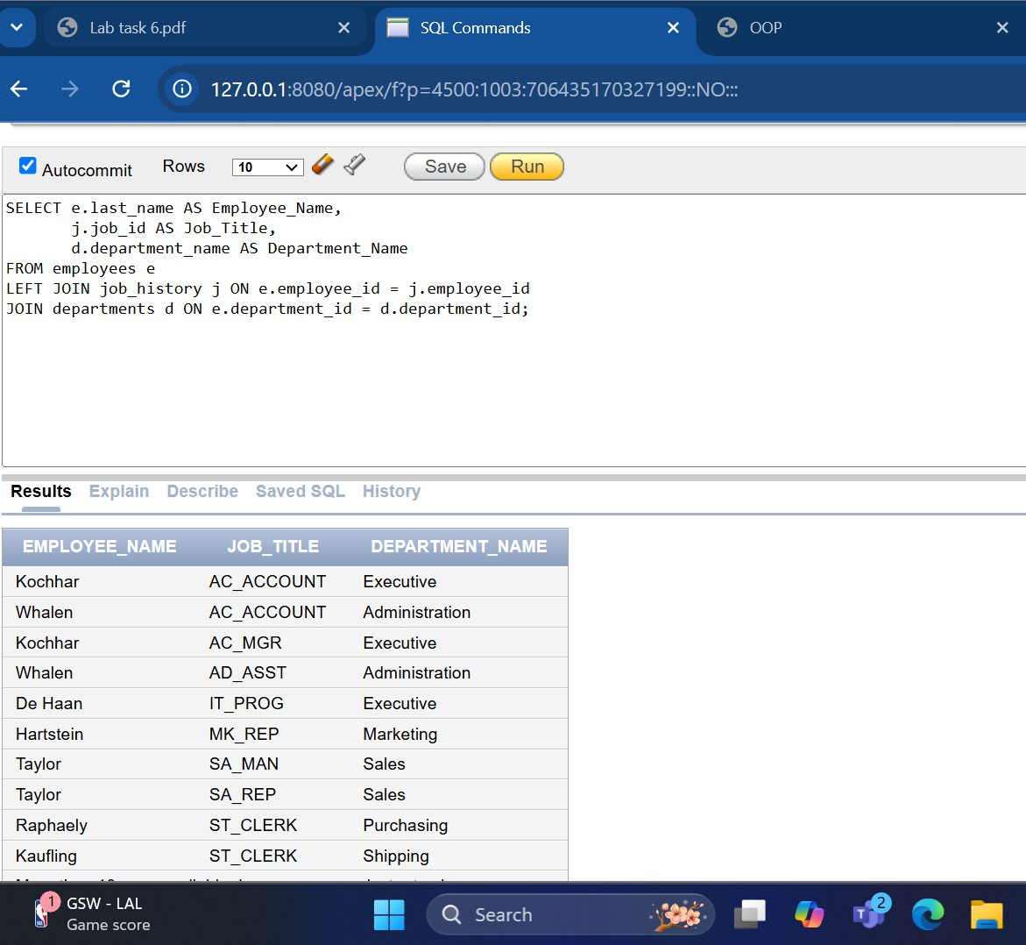

Q5. Write a query join employees and job_history table to get the current job title and department name of each employee.

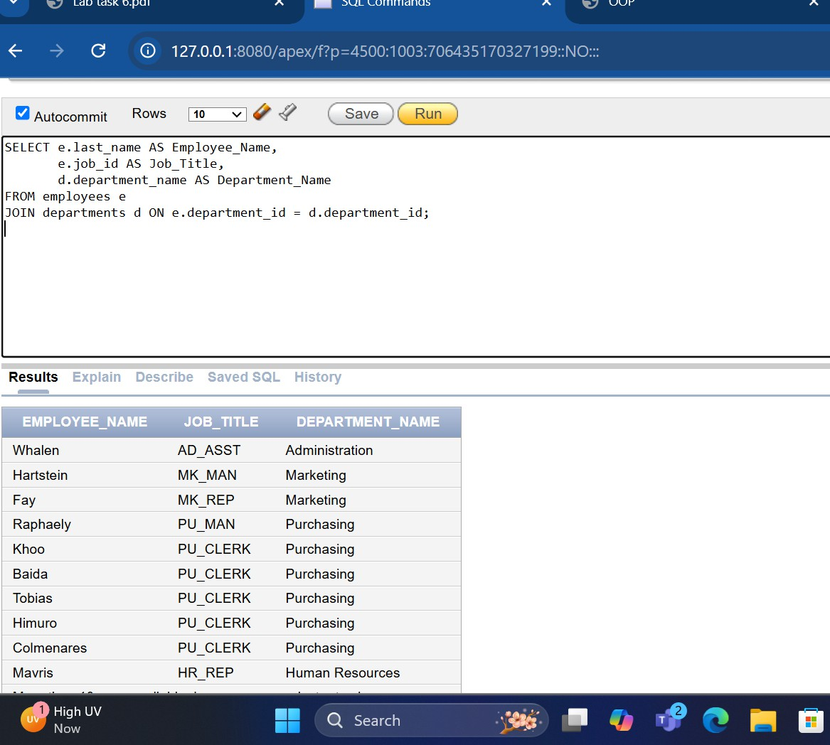

LAB TASK : 07

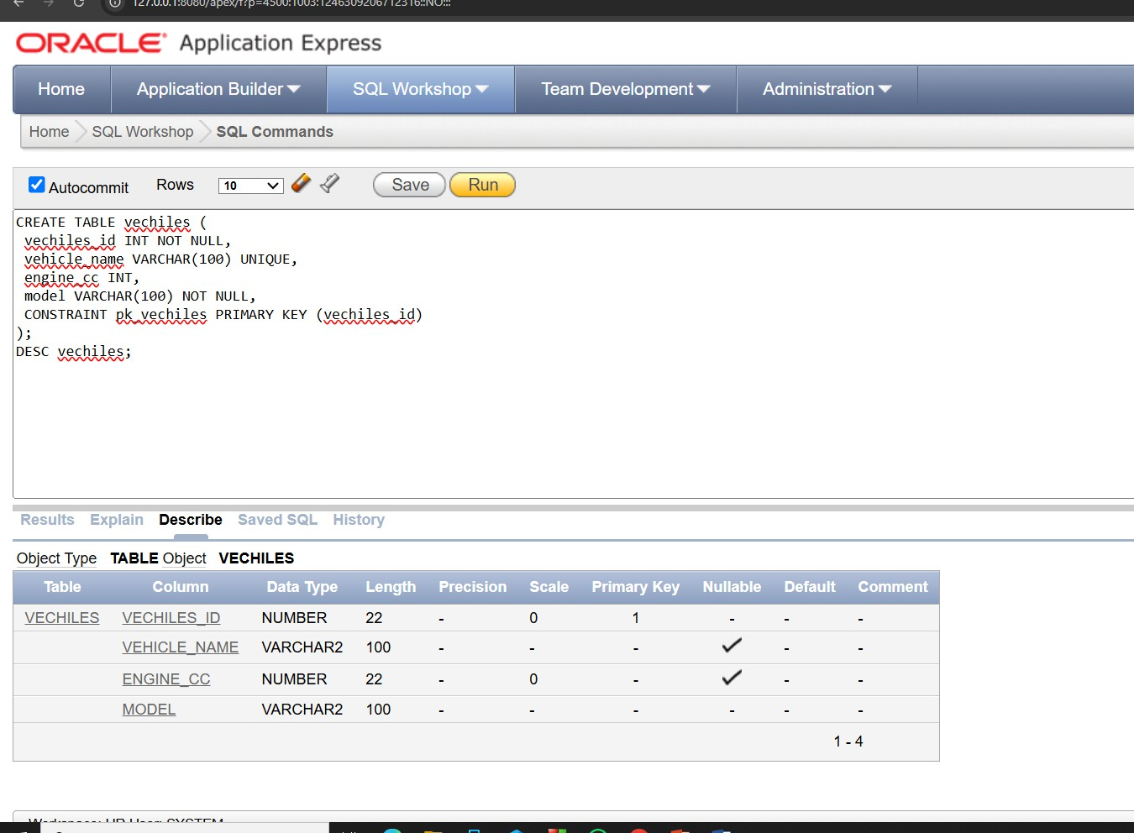Q2 :

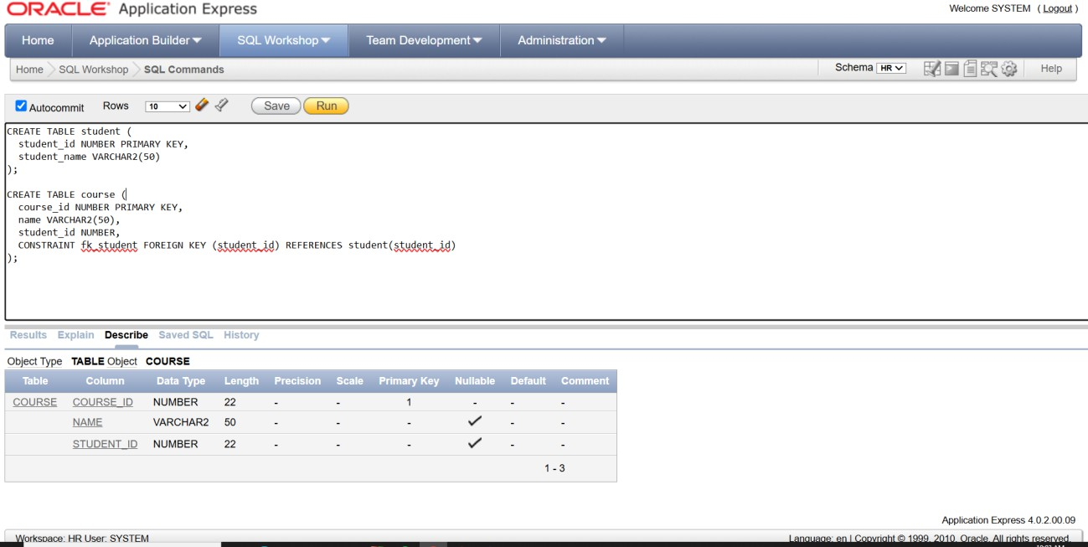**Q3 :**

**Q4:**

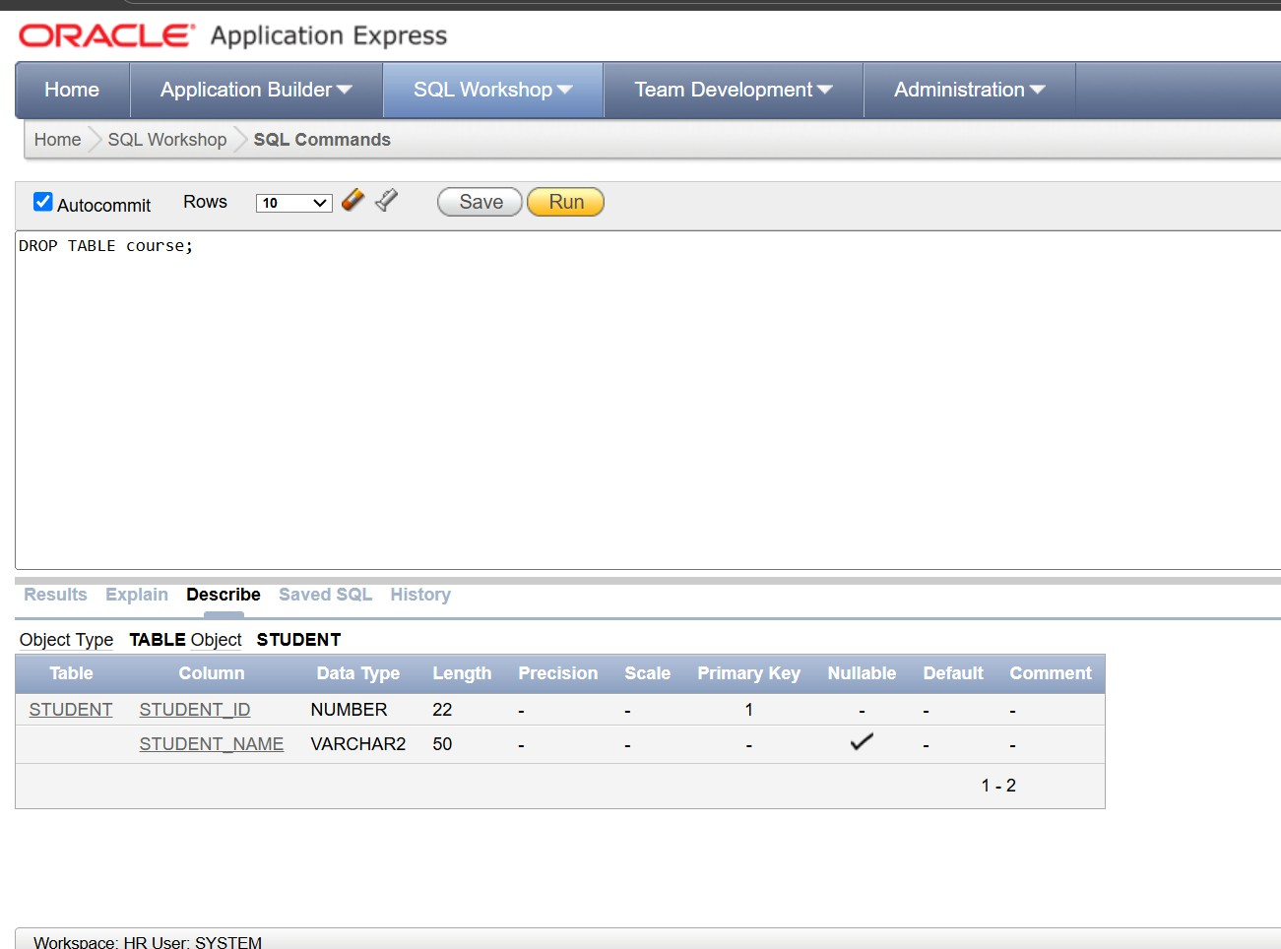

**Q5:**

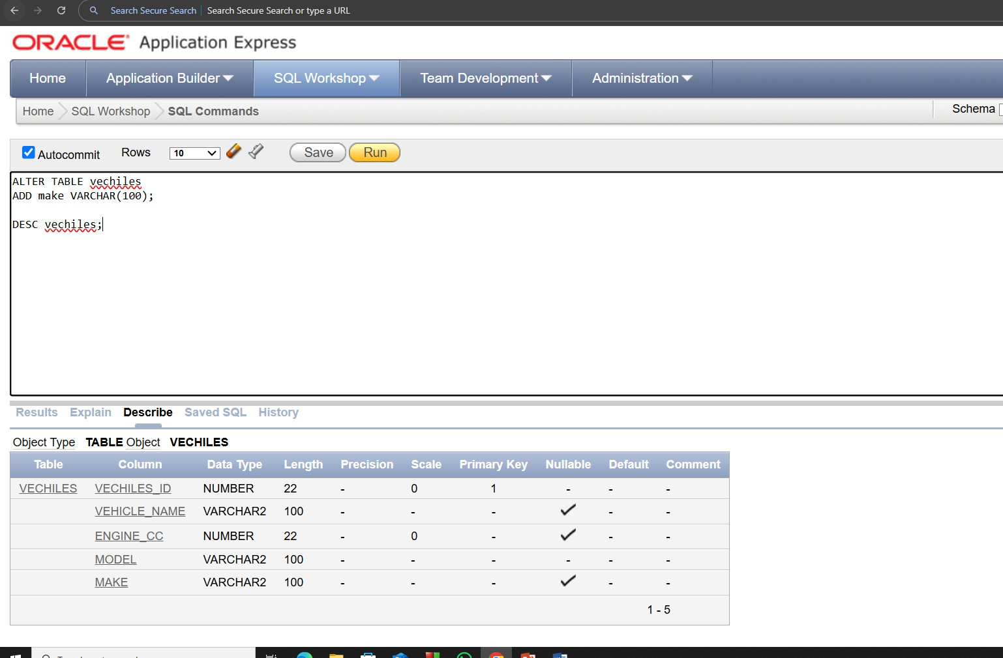

**Q6:**

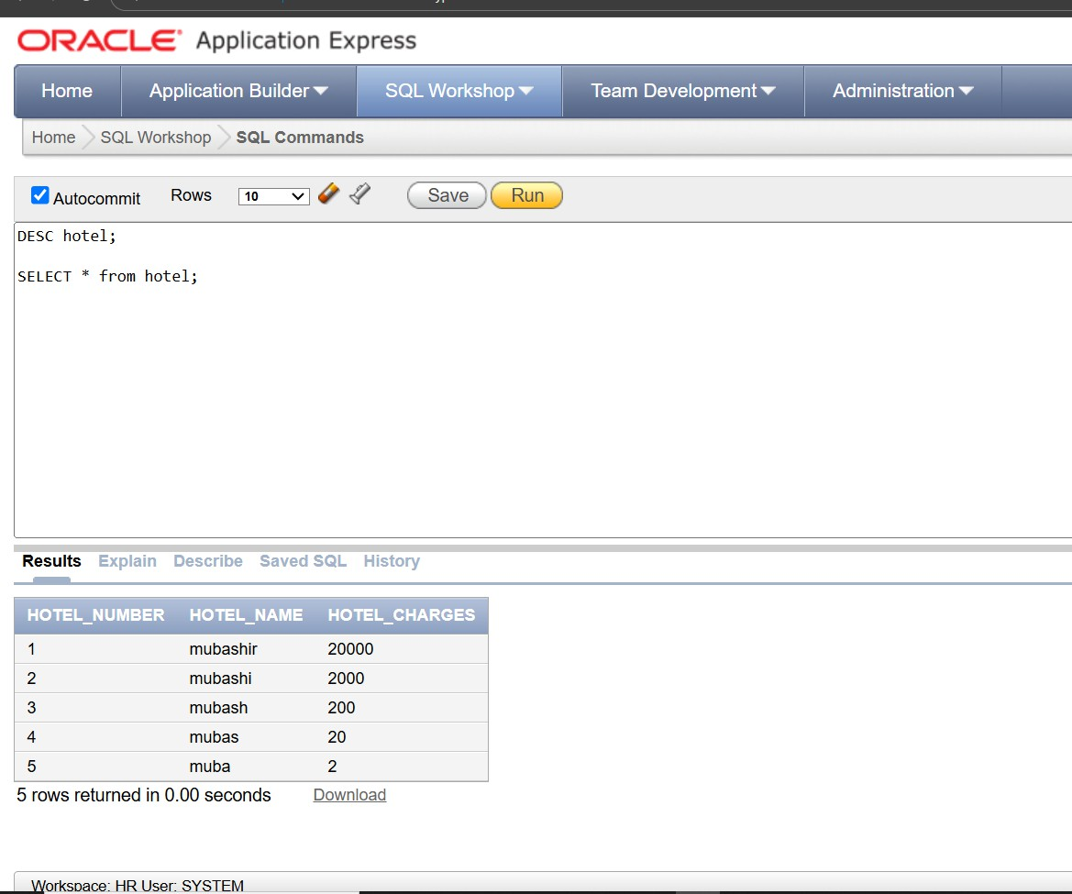

**LAB TASK : 08**

Table create :

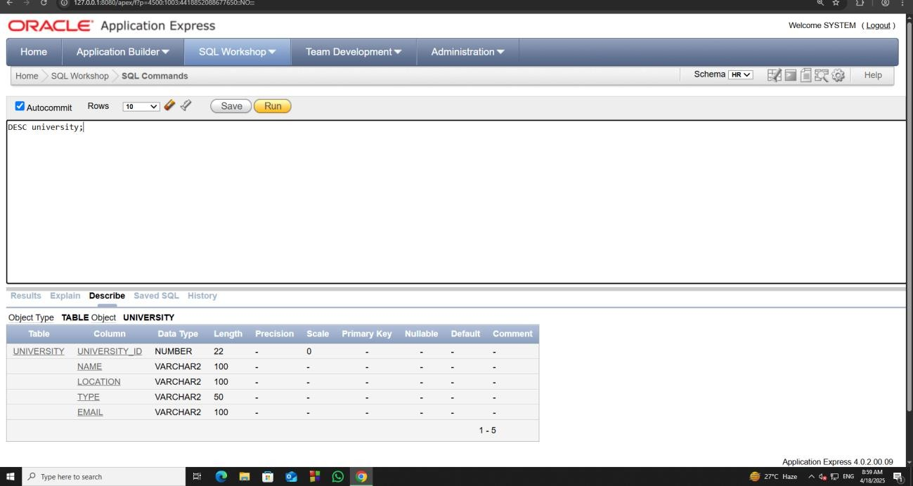

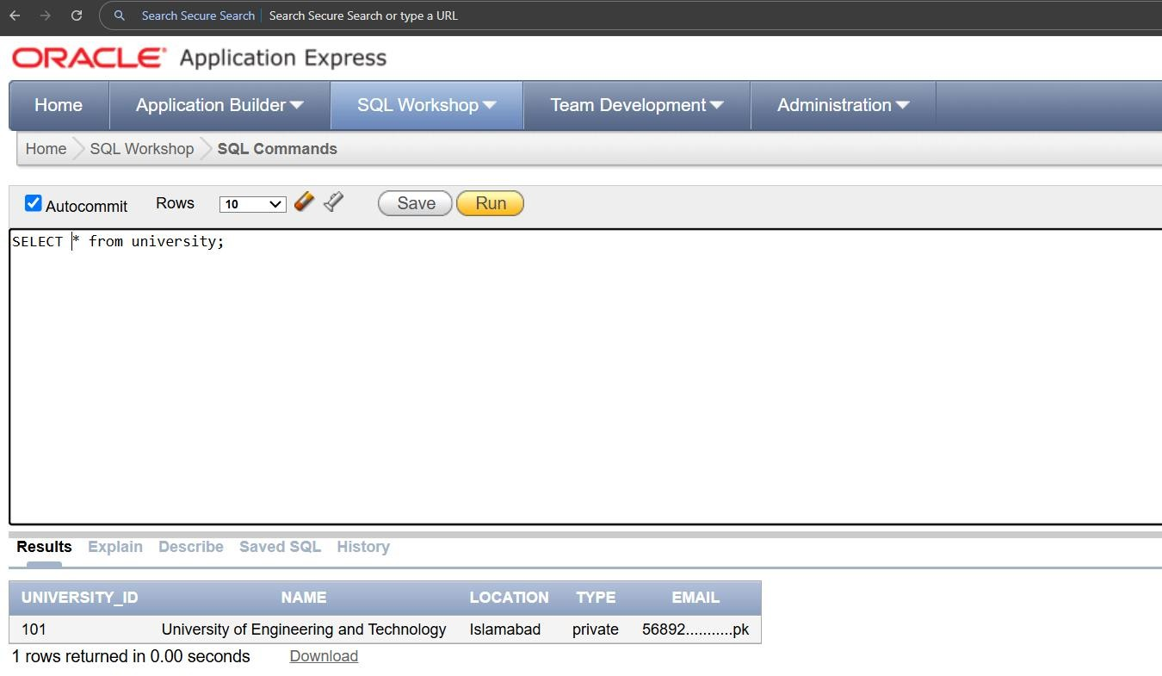Insertion :

Update Function :

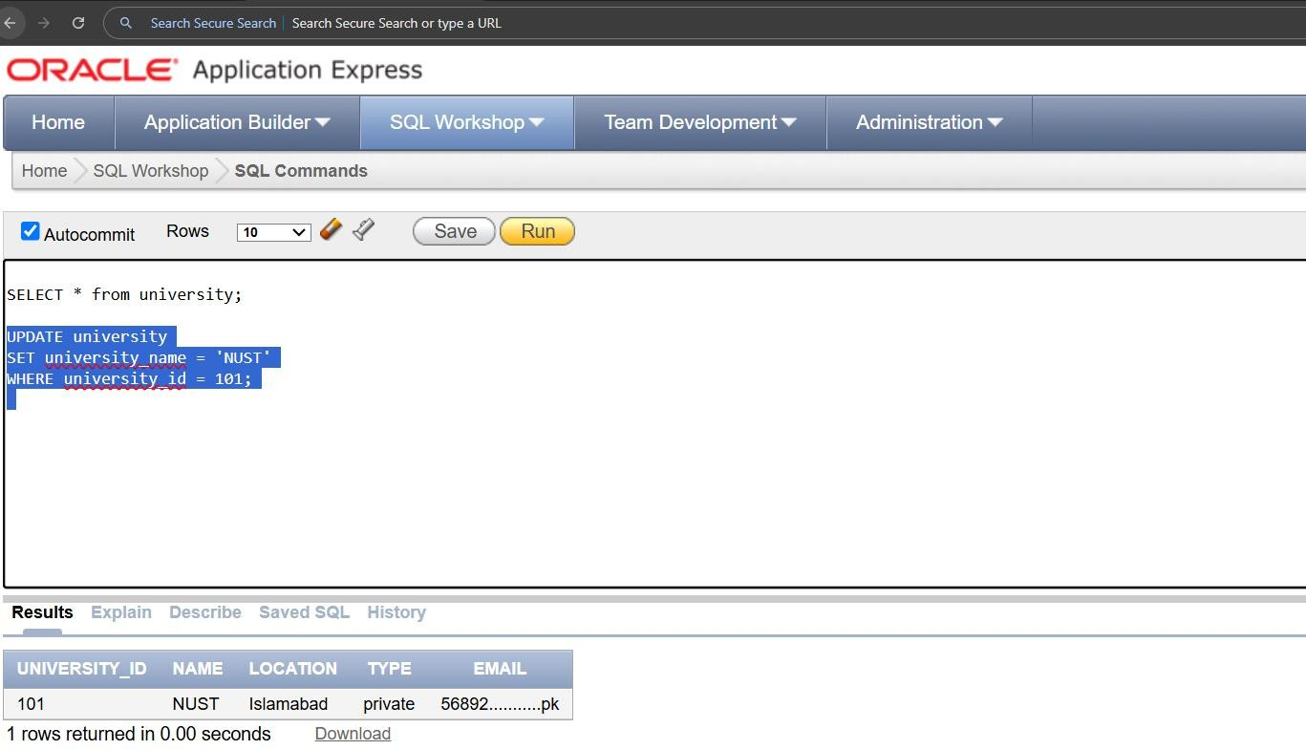

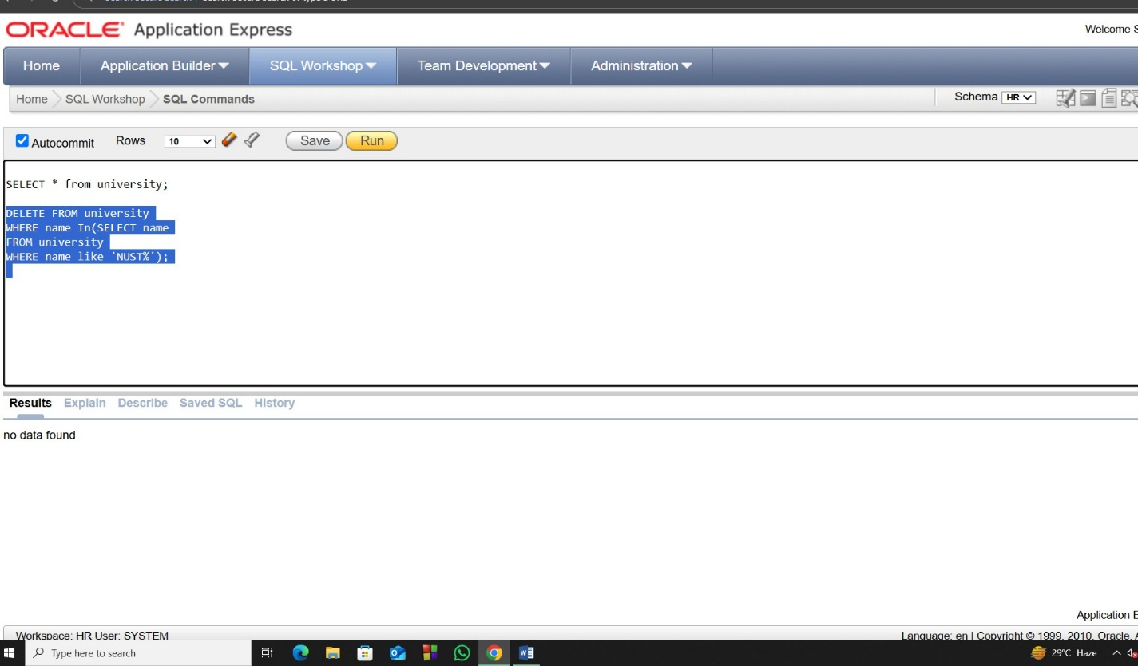Delete function :

TASk Q3

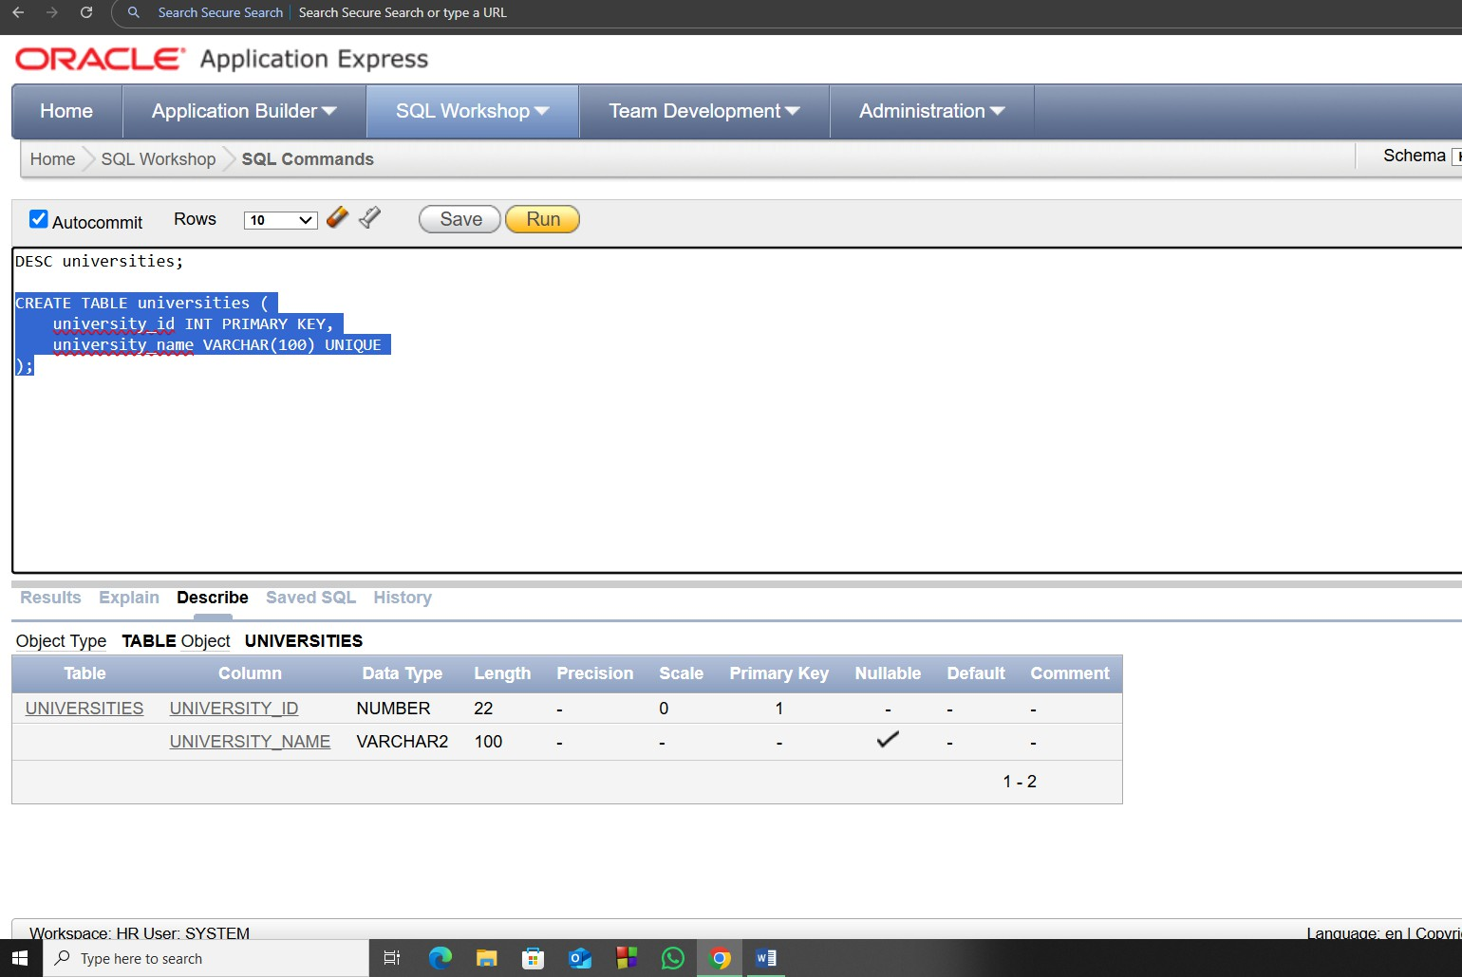

**Q3(2):**

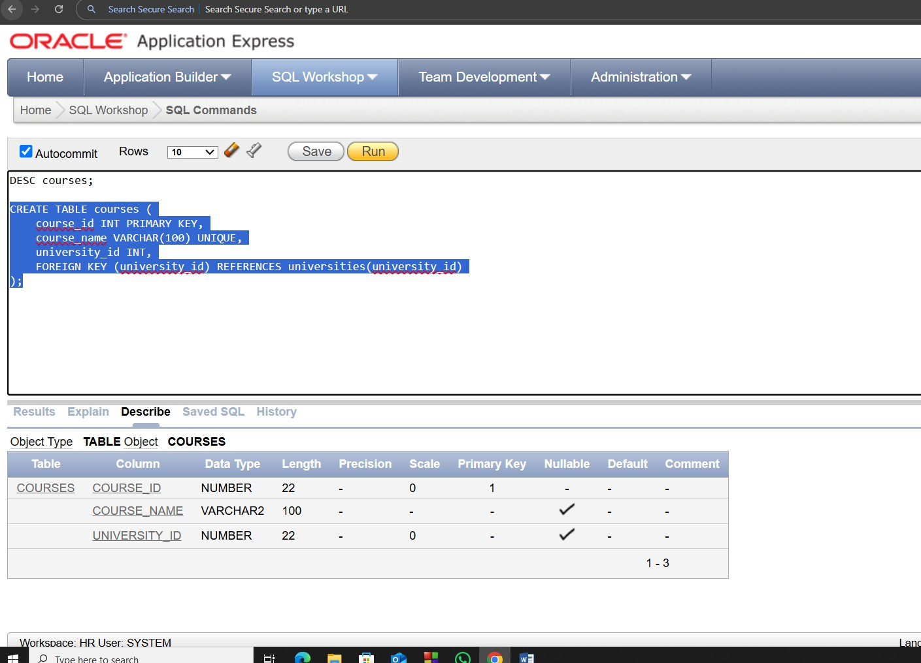

**Q3(3):**

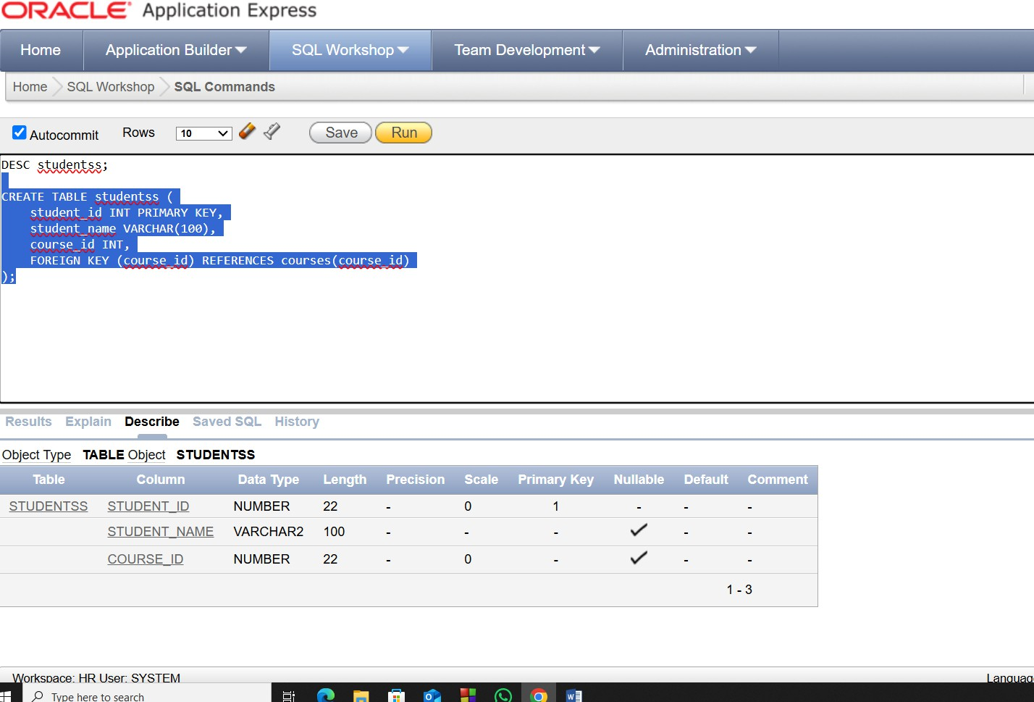

**Q4 :**

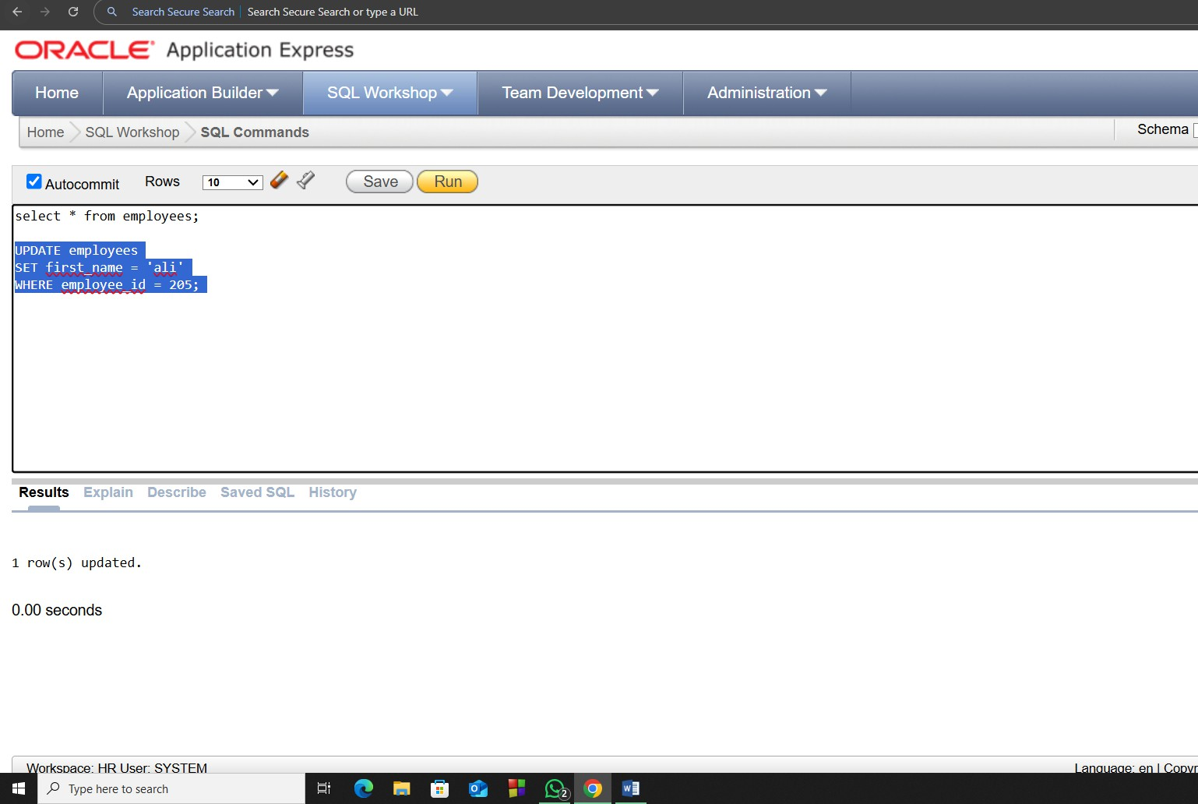

LAB TASK : 09

1

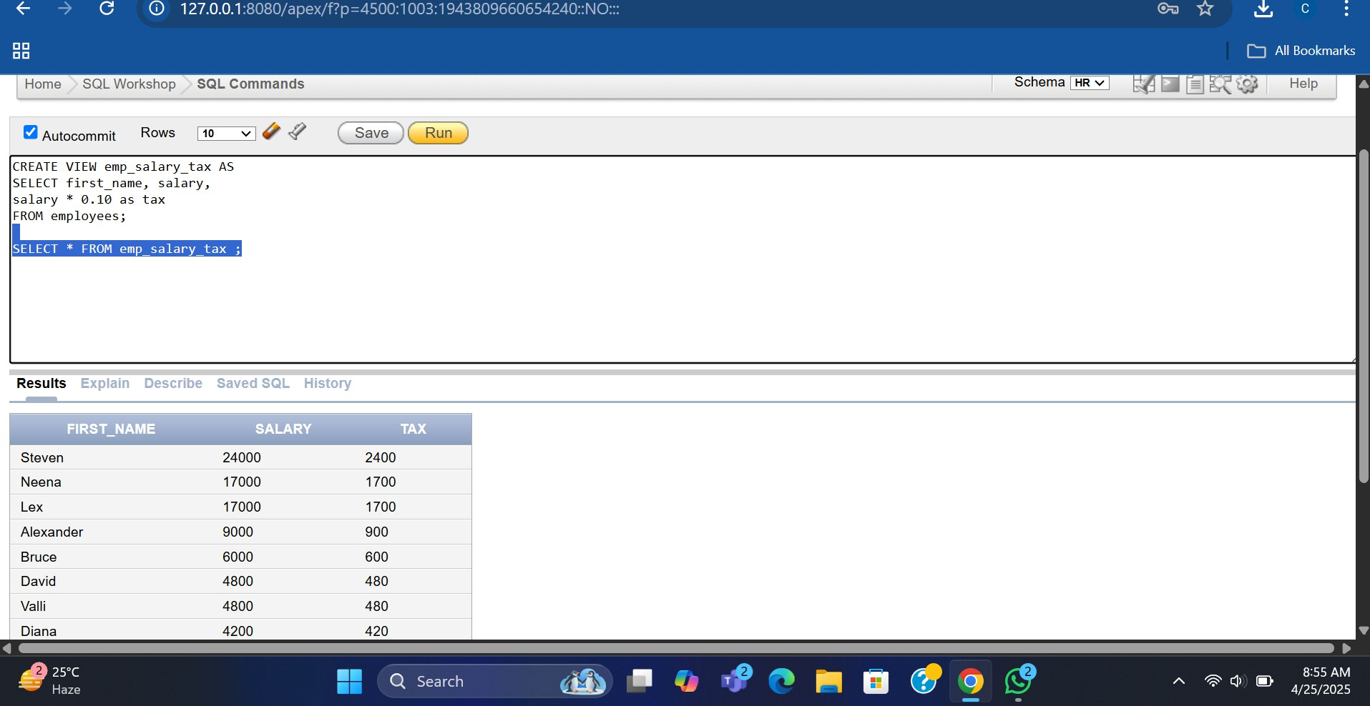

2:

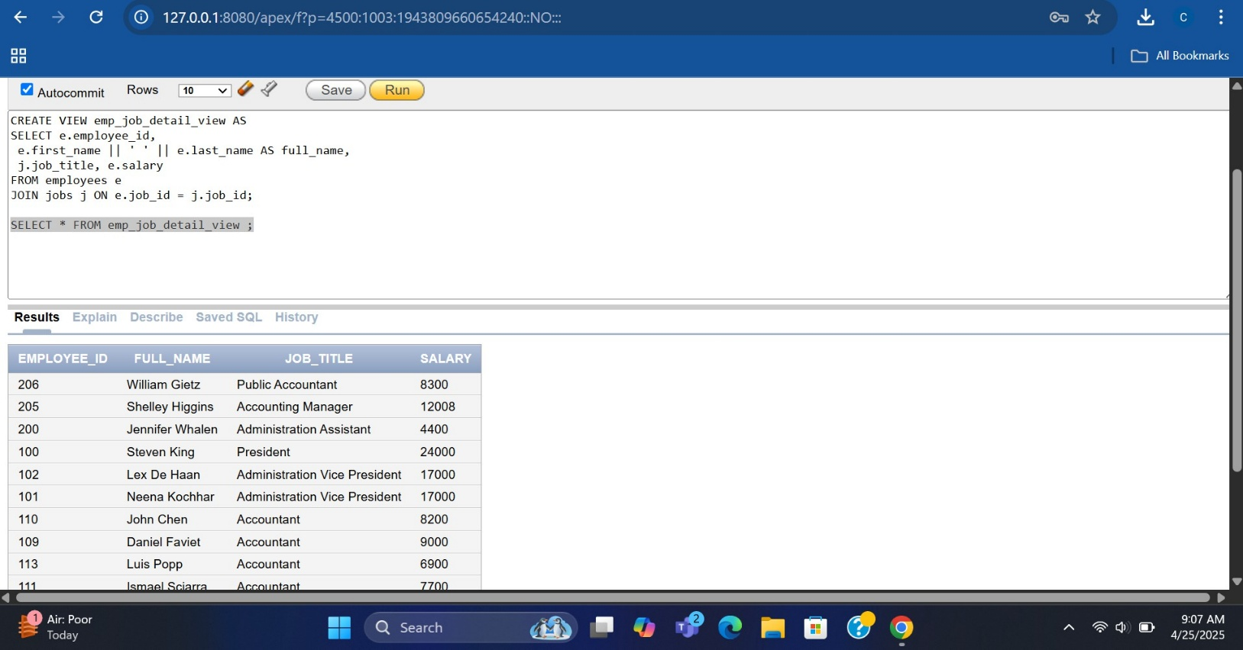

3:

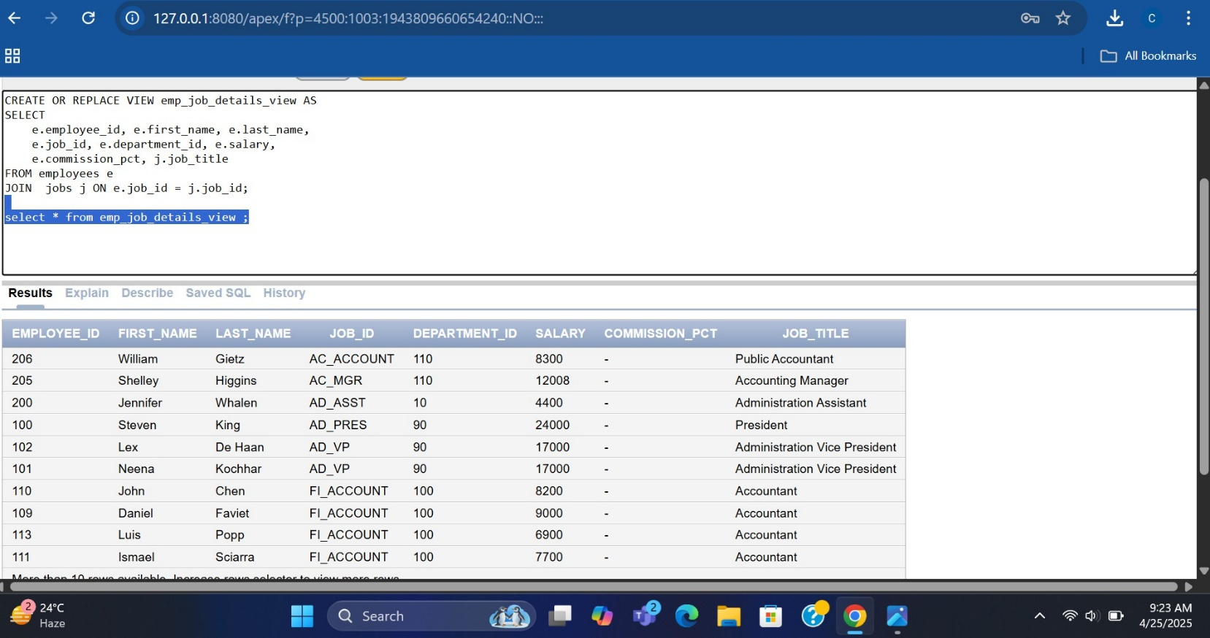

4:

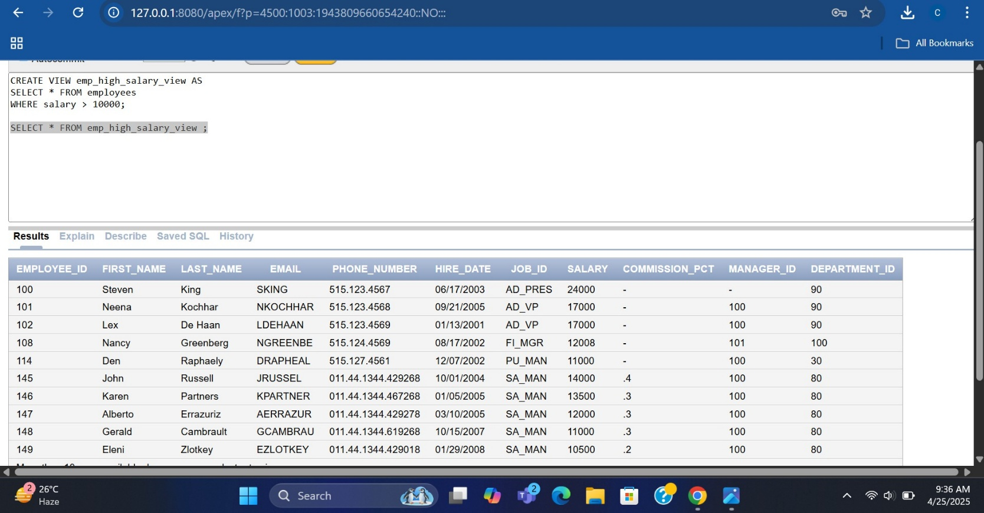

5:

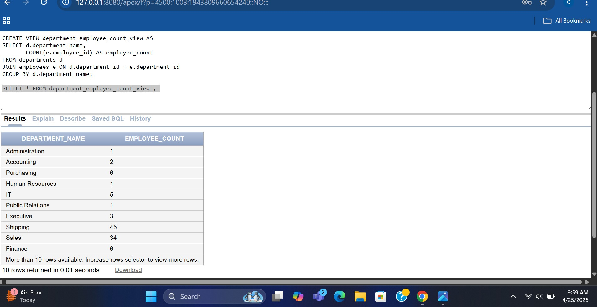

6:



7:

This query retrieves all rows from the emp_dept_view. The output shows each department's name along with the total number of employees in that department, as defined by the view logic. If the view uses an INNER JOIN, only departments with at least one employee will

appear.

Lab Task 10.

Library Fine Tracking System

Real-World Case:

When a member borrows a book and returns it late, the system:

* **Automatically calculates the late fine.**
* **Updates the member’s total dues.**
* **Logs a fine record.**

1. **Create Tables :**

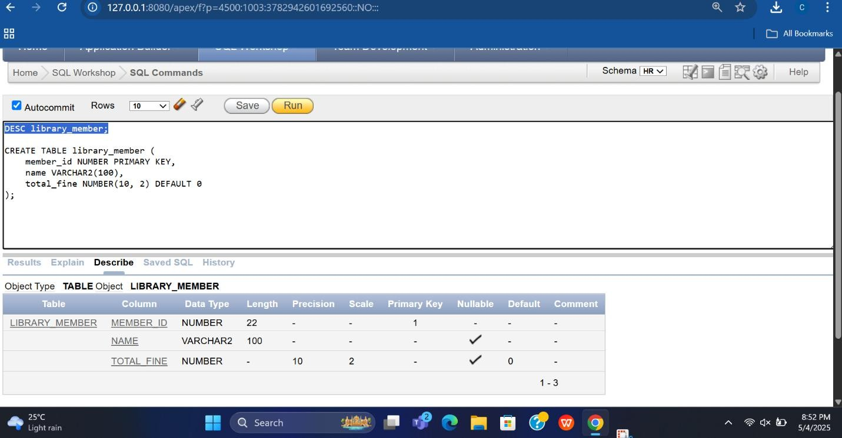

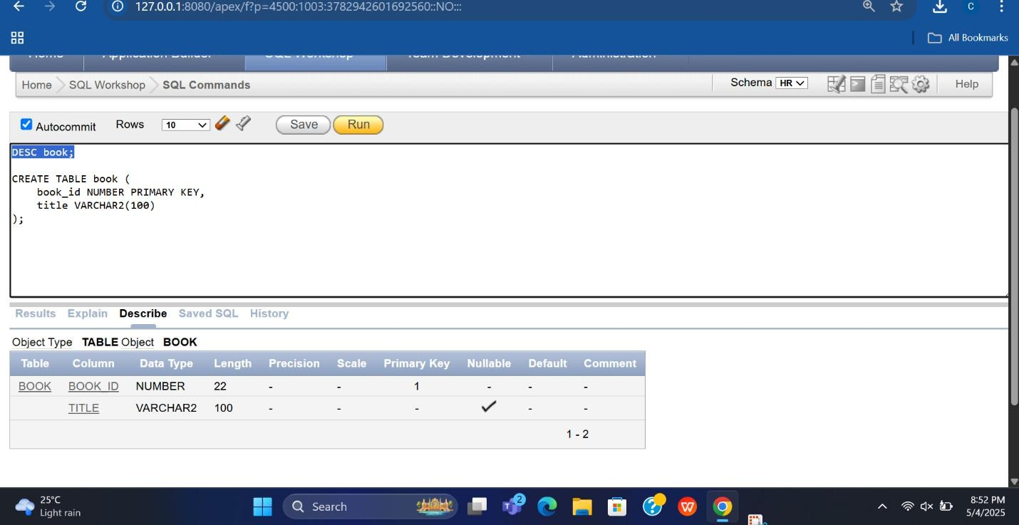(ii)

(iii) :

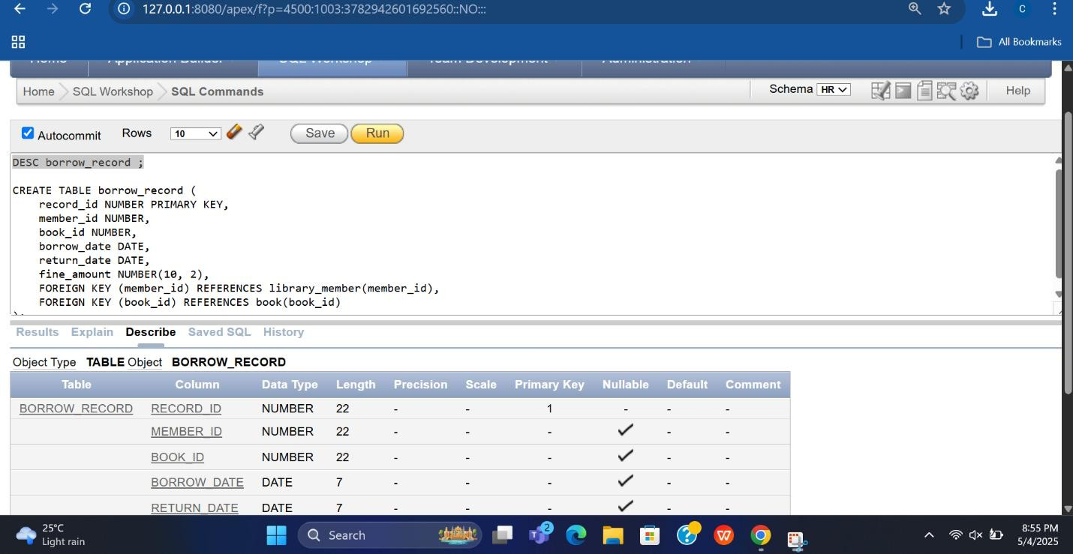

1. 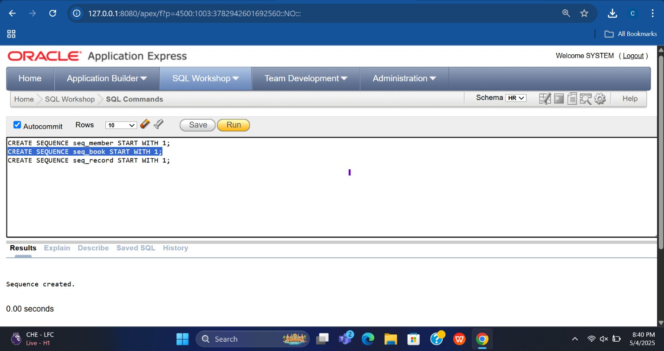**Create Sequences**
2. 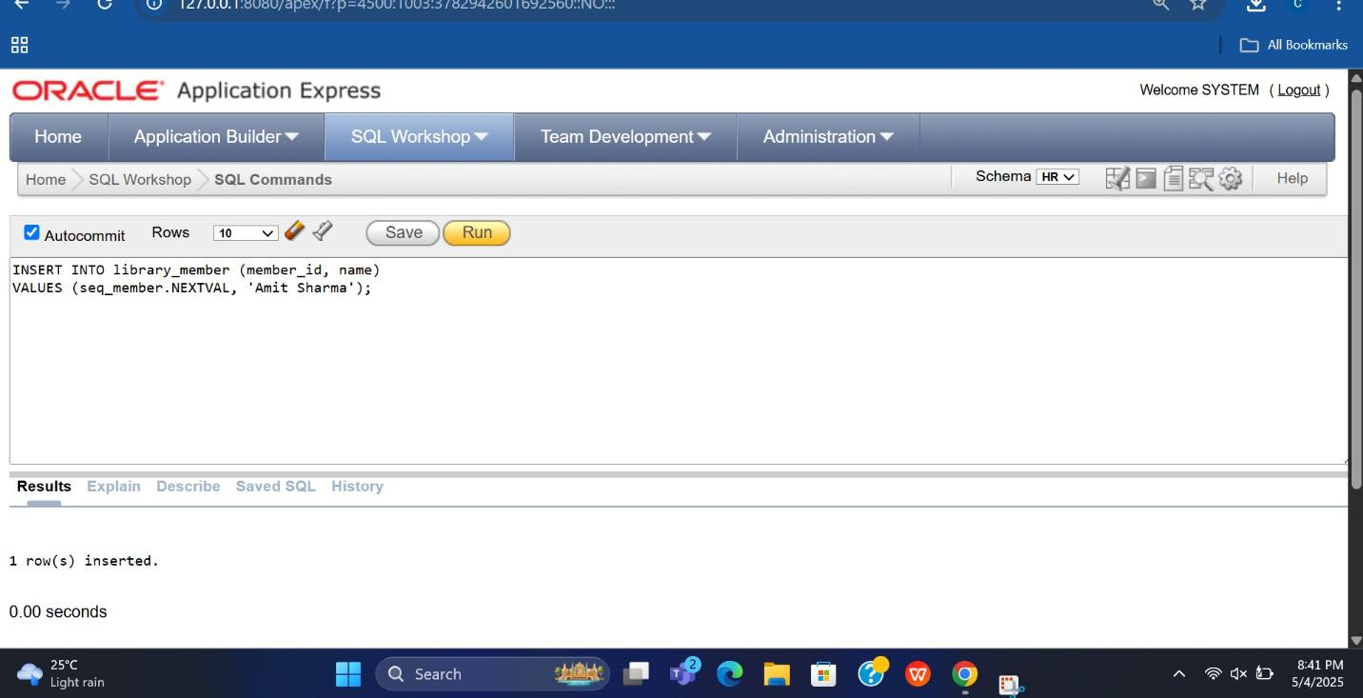**Insert Sample Data**

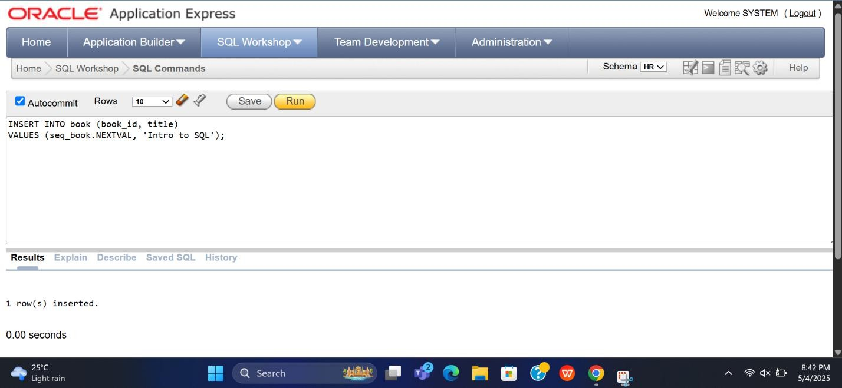(ii)

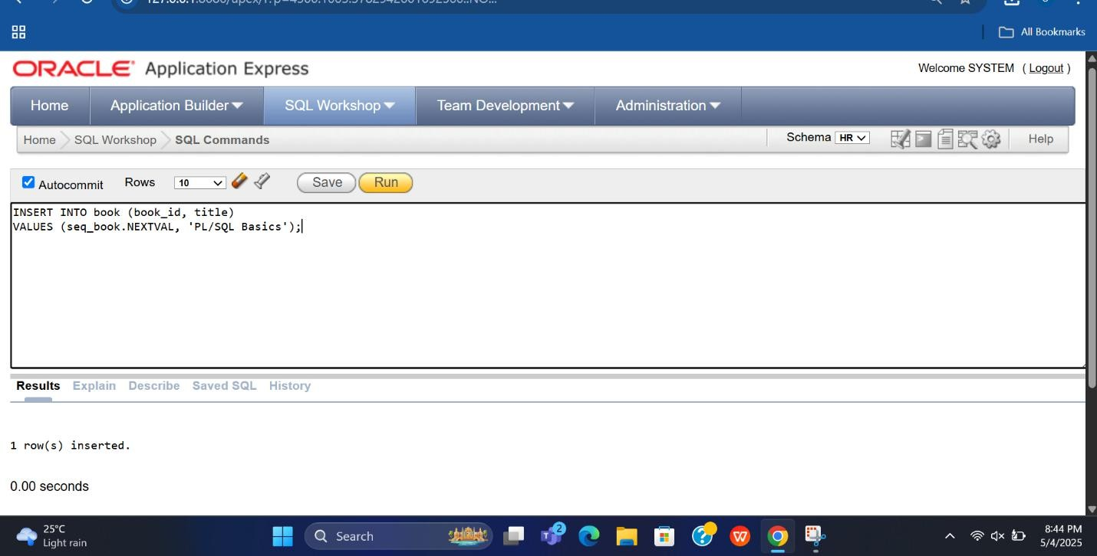(iii)

1. **Create Trigger to Calculate Late Fine**

Assume:

* **Borrow period = 7 days**
* **Fine = ₹5 per late day**

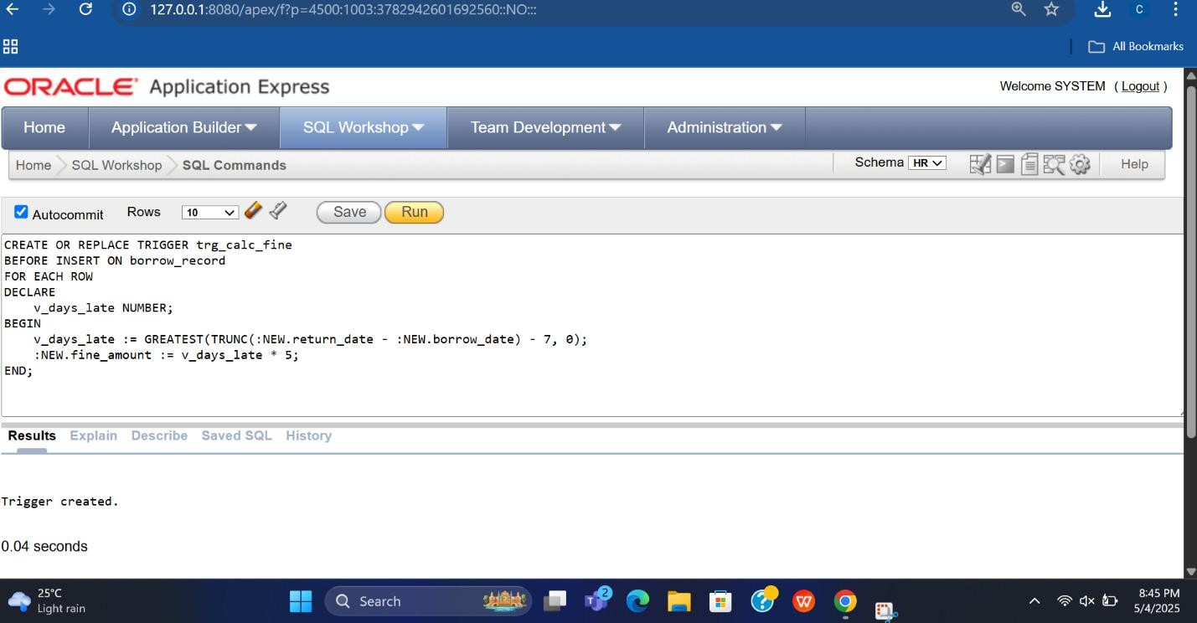

1. 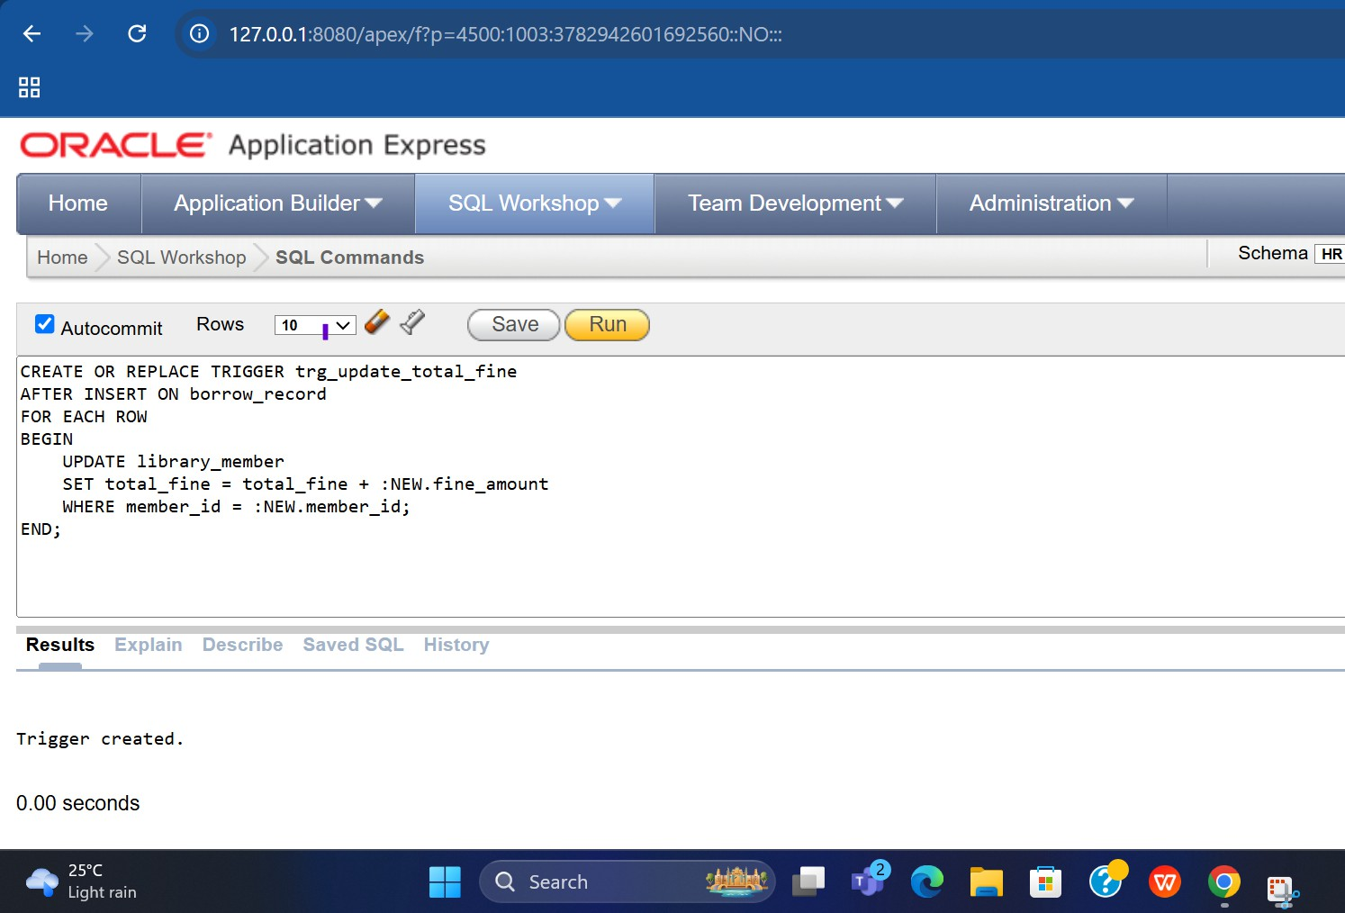**Trigger to Update Total Fine for Member.**

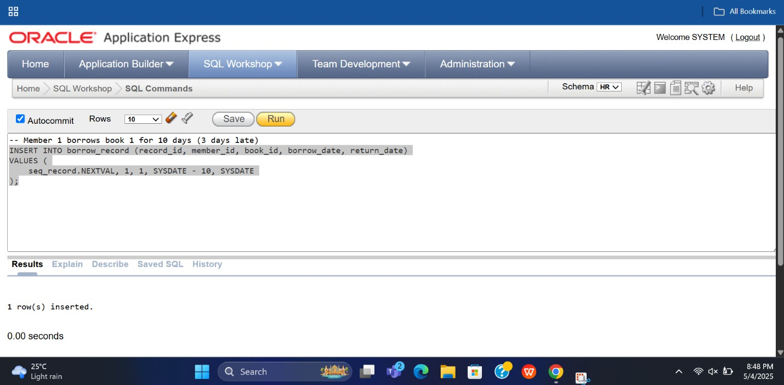**Test the System.**

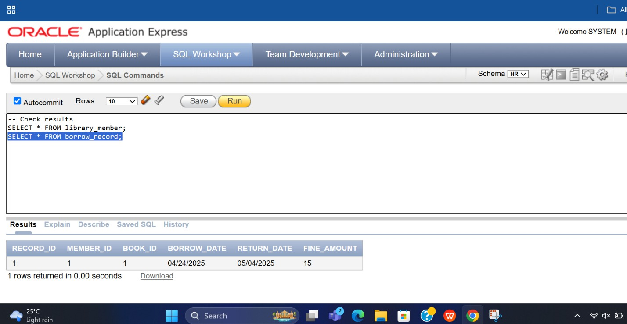**Result :**

**Lab Task : 11.**

**Assignment Title: Designing a Database using CockroachDB.**

1. **Selection of Application and Database Tool**

* **Application**: Hotel Booking Management System
* **Database Tool**: CockroachDB

2. **System Analysis**

**Key Entities**

* **Customers** – Individuals booking hotel rooms
* **Rooms** – Hotel room details
* **Bookings** – Reservation records
* **Payments** – Payment info for bookings
* **Services** – Additional services used by customers (e.g., laundry, meals).

**3. Creating a DATABASE :**

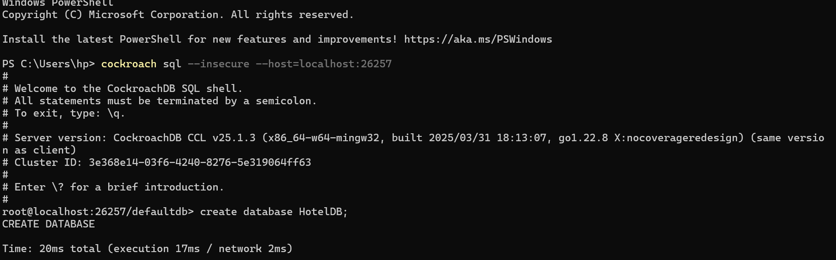

**4. Schema Design and SQL Implementation :**

**Creating a tables :**

* **Customers**

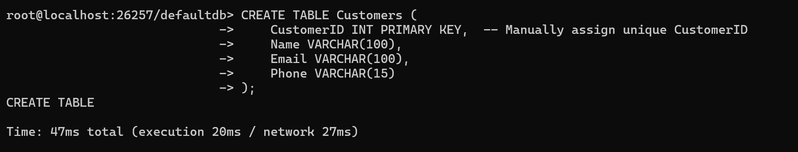

* **Rooms**

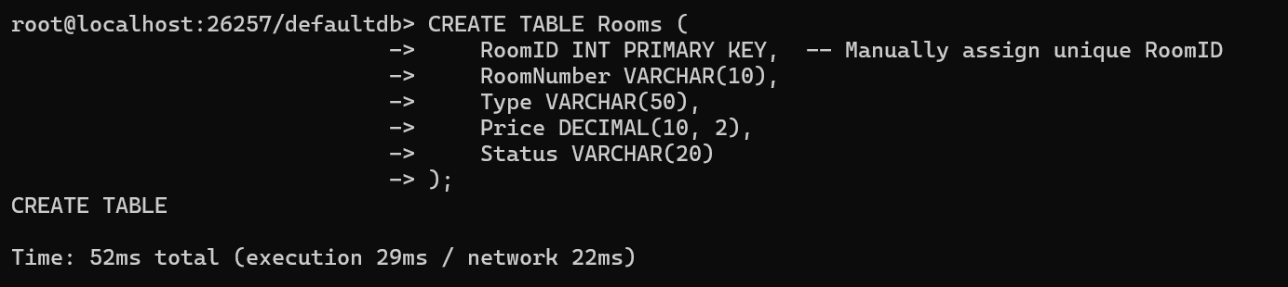

* **Bookings** & **Payments**

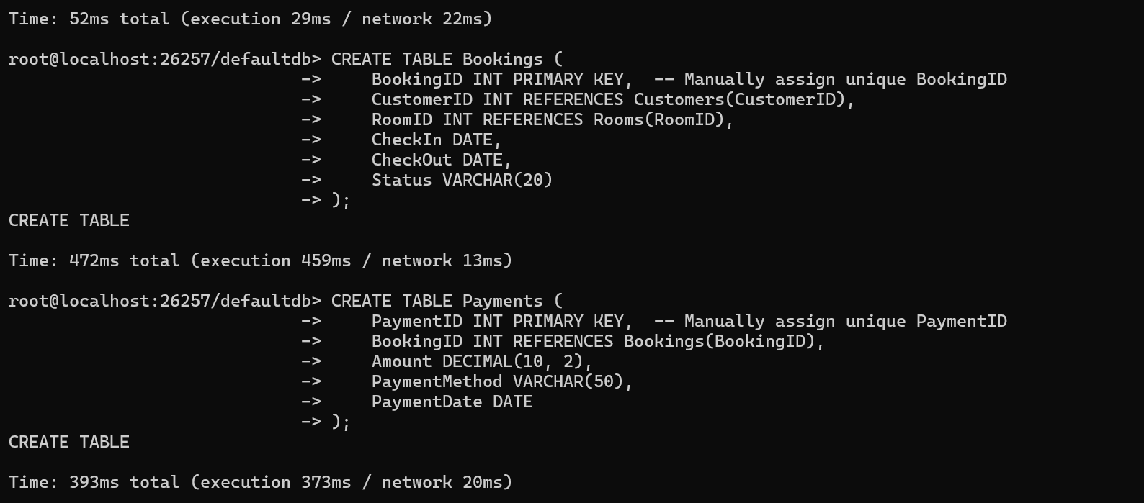

* **Services** –

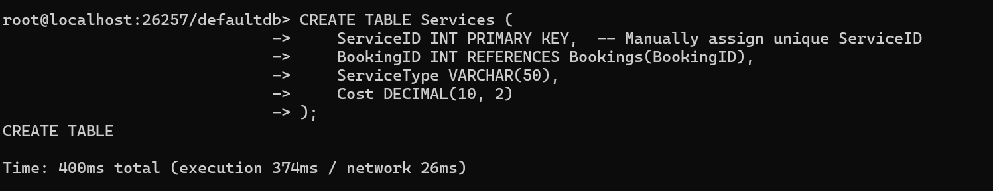

**5 Sample Data Insertion**

Insert into -- Customers

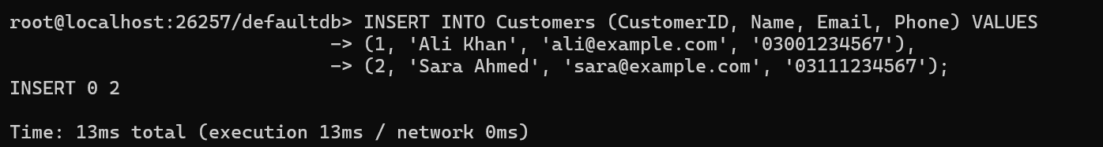

Insert into -- Rooms

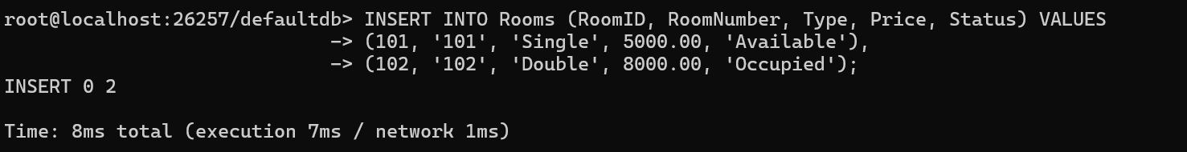

Insert into -- Bookings & Payments & Services .

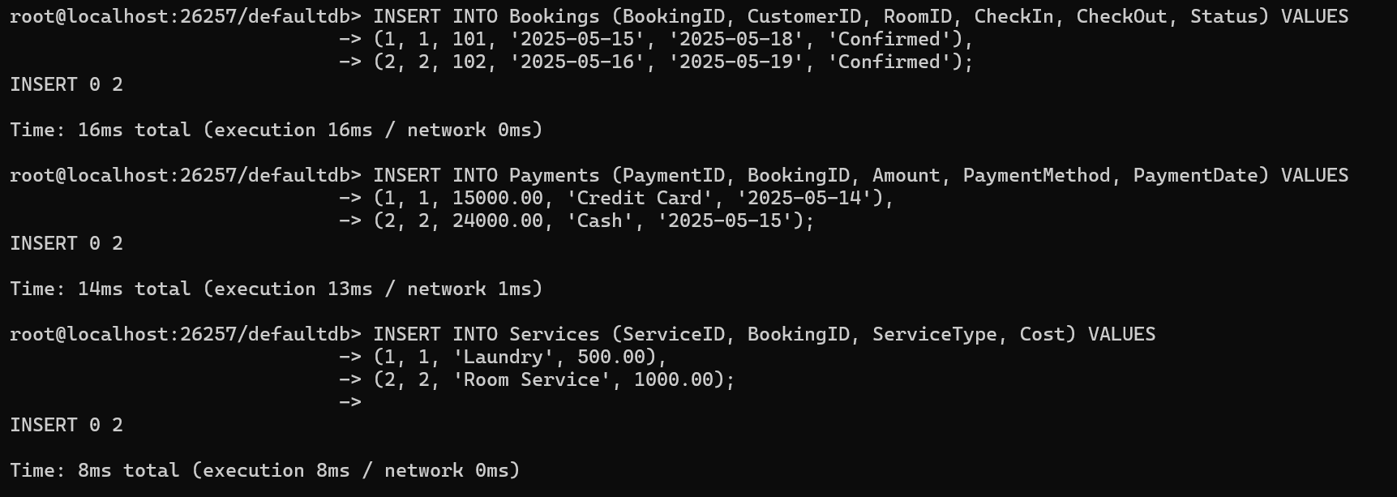

**5. SQL Query Execution :**

**1. SELECT Statements – Retrieving Records:**

**a. Retrieve all customers with contact info**

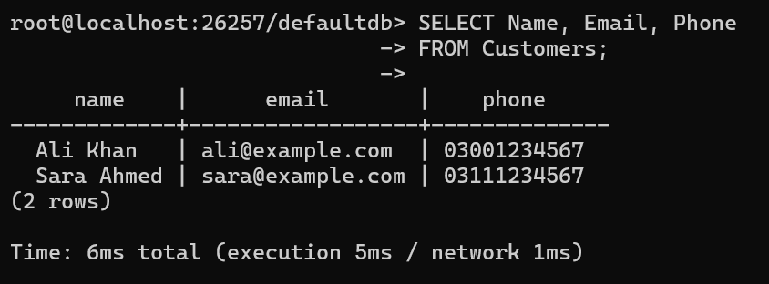

**b. Get all available rooms**

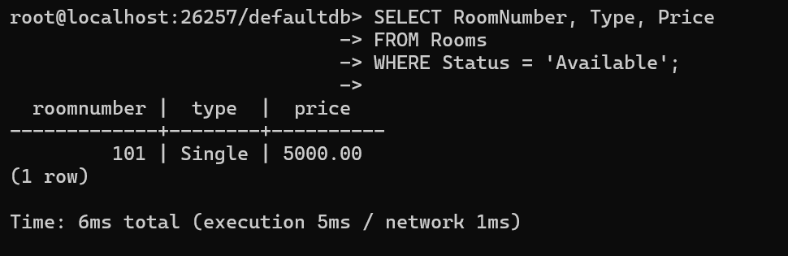

**c. Get bookings between two dates**

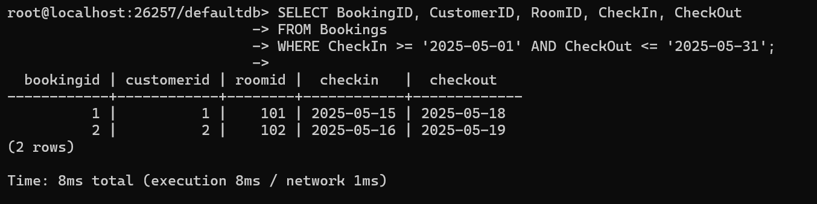

**2. JOIN Operations – Combining Data from Multiple Tables**

a. Show booking details with customer and room info

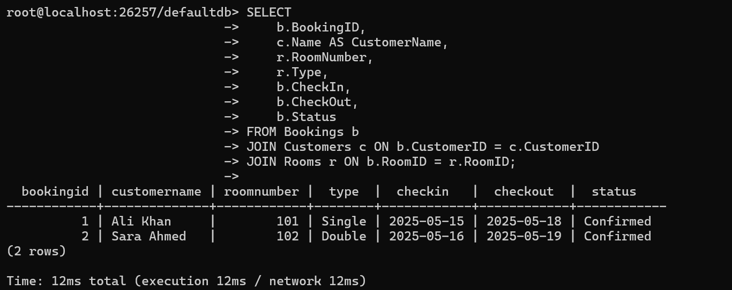

**b. Get payment history with customer and amount**

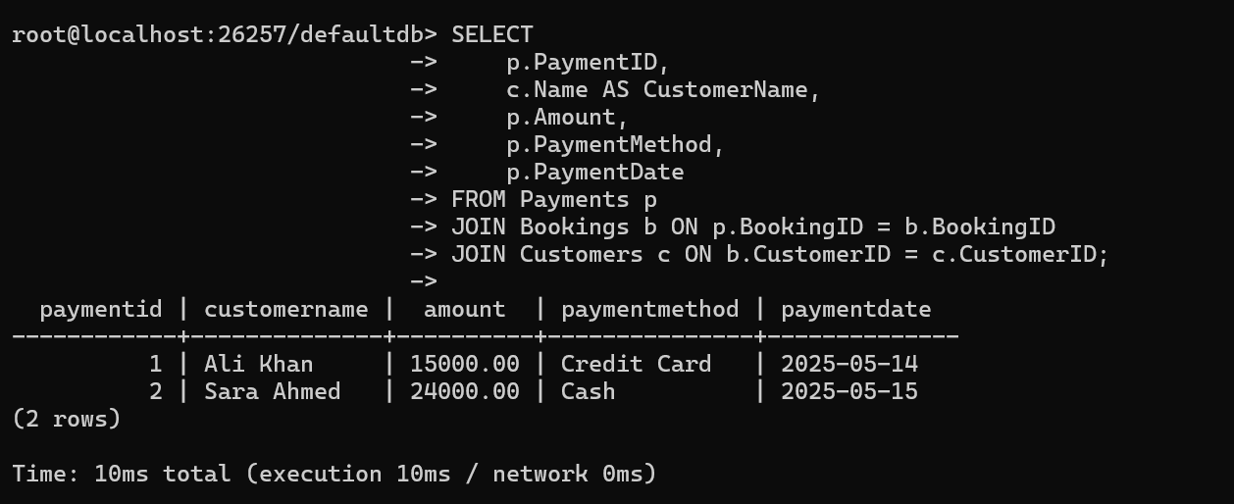

**c. List services used per booking with cost**

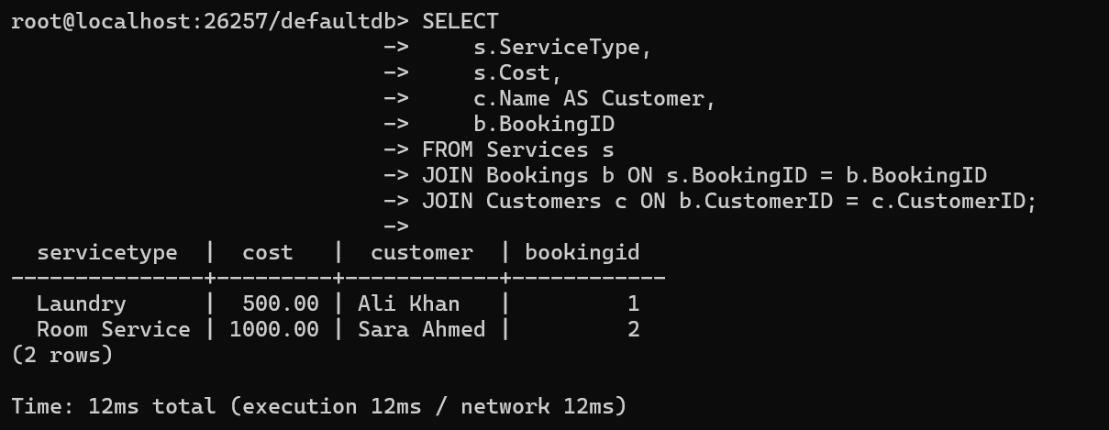

**3. UPDATE Queries – Modifying Records**

a. Mark a room as "Occupied" after booking

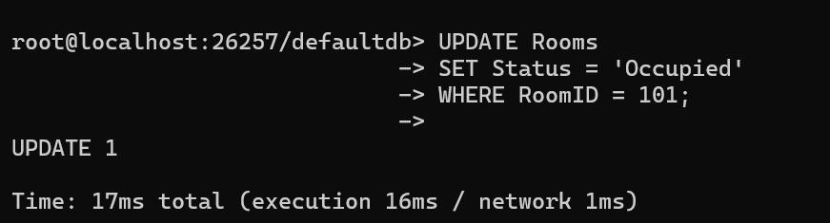

**b. Update booking status to "Completed" & Change customer contact info**

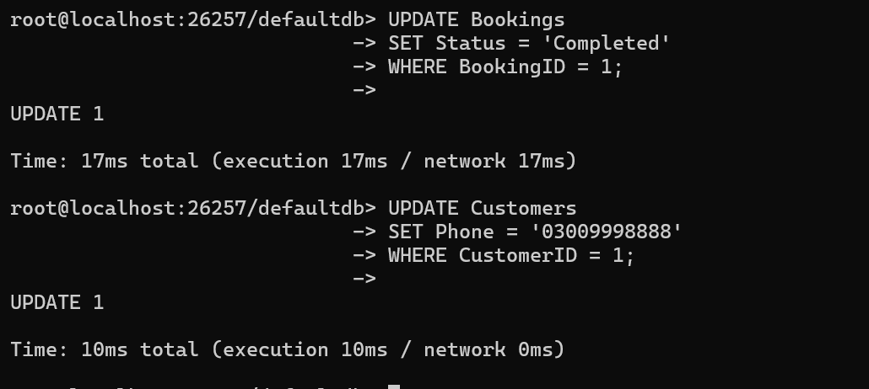

**Recheck the updated status**

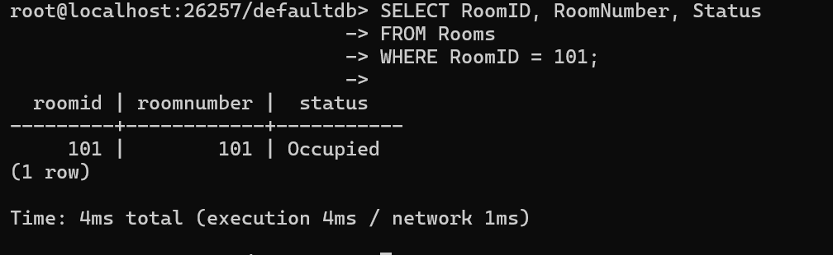

**Complex Query with Aggregation**

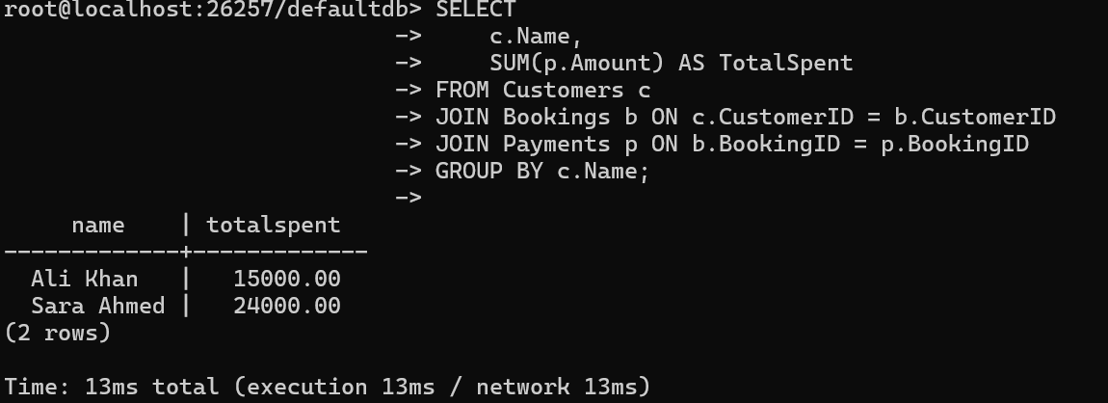

**Entities and Attributes**

**1. Customers**

* CustomerID (Primary Key)
* Name
* Email
* Phone

**2. Rooms**

* RoomID (Primary Key)
* RoomNumber
* Type (e.g., Single, Double, Suite)
* Price
* Status (e.g., Available, Occupied)

**3. Bookings**

* BookingID (Primary Key)
* CustomerID (Foreign Key → Customers)
* RoomID (Foreign Key → Rooms)
* CheckIn (Date)
* CheckOut (Date)
* Status (e.g., Confirmed, Cancelled, Completed)

**4. Payments**

* PaymentID (Primary Key)
* BookingID (Foreign Key → Bookings)
* Amount
* PaymentMethod (e.g., Cash, Credit Card)
* PaymentDate

**5. Services**

* ServiceID (Primary Key)
* BookingID (Foreign Key → Bookings)
* ServiceType (e.g., Laundry, Room Service)
* Cost

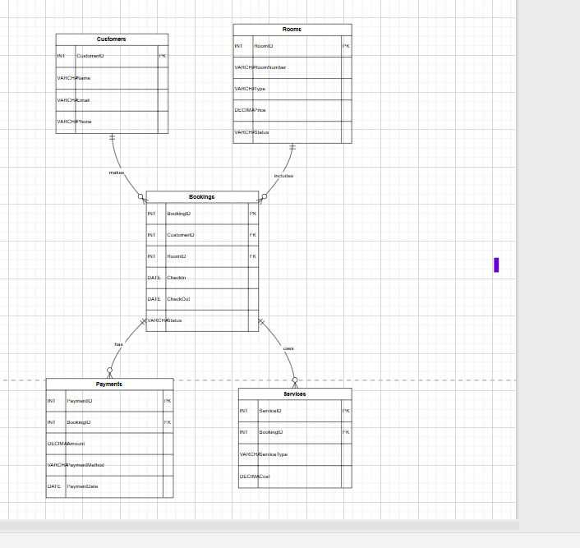

**______________________________END____________________________________________**